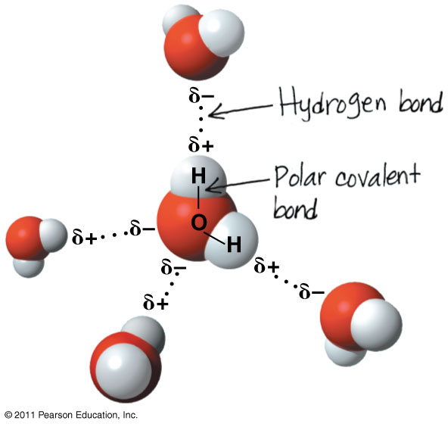
WATER and LIFE
Water: The Molecule That Supports All of Life
Polar covalent bonds in water molecules result in hydrogen bonding
- polar molecule -

Four properties that facilitate an environment for life are:
  - Cohesive behavior
  - Ability to moderate temperature
  - Expansion upon freezing
  - Versatility as a solvent
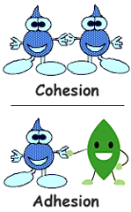
Cohesion and Adhesion of Water Molecules

- Hydrogen bonds hold water molecules together, (a phenomenon called cohesion)
- Cohesion helps the transport of water against gravity in plants
- an attraction between different substances, for example, between water and plant cell walls
- Surface Tension

How does water moderate temperature?

Remember…
- Kinetic energy is the energy of motion
- Heat is a measure of the total amount of kinetic energy due to molecular motion
- Temperature measures the intensity of heat due to the average kinetic energy of molecules
What is Specific Heat?

Water has a high specific heat!

  - Heat is absorbed when hydrogen bonds break
  - Heat is released when hydrogen bonds form
The high specific heat of water minimizes temperature fluctuations to within limits that permit life
What is Evaporative Cooling?

- Heat of vaporization -

Water is Special! It has special properties that other compound don’t…
Liquid water:
Hydrogen bonds
break and re-form
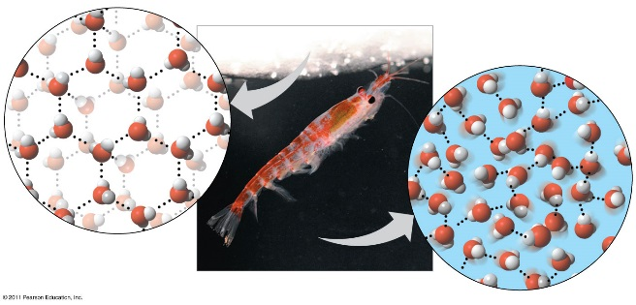
Like how ice floats on liquid water…

- .
- .
Ice:
Hydrogen bonds
are stable
And …

So… they say
“Water is The Solvent of Life”

Some vocab…
- A solution is a liquid that is a homogeneous mixture of substances
- A solvent is the dissolving agent of a solution
- The solute is the substance that is dissolved
- An aqueous solution is one in which water is the solvent

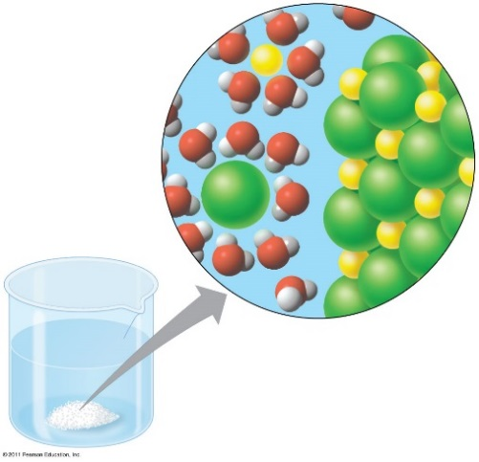
What makes water such a versatile solvent??
Na⁺
- .

- .
Cl⁻

- .

- .

Hydrophilic and Hydrophobic Substances

- Oil molecules are hydrophobic because they have relatively nonpolar bonds
- A colloid is a stable suspension of fine particles in a liquid

Most biochemical reactions occur in water
Chemical reactions depend on …
- 1.

- 2.

Acidic and basic conditions and living organisms
- Living organisms are affected by acidic and basic conditions
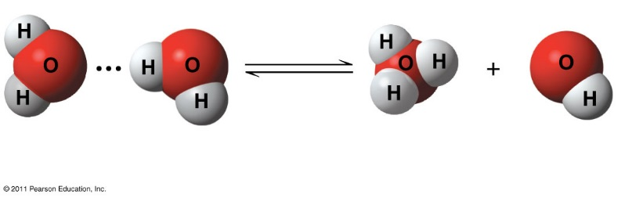
Acid and Base Review:

A hydrogen atom in a hydrogen bond between two water molecules can shift from one to the other
  - The hydrogen atom leaves its electron behind and is transferred as a hydrogen ion (H⁺)
  - The molecule with the extra proton is now a hydronium ion (H₃O⁺)
    - it is often represented as H⁺
  - The molecule that lost the proton is now a hydroxide ion (OH–
Water is in a state of dynamic equilibrium
  - .
- .
- .
- Changes in concentrations of H⁺ and OH– can drastically affect the chemistry of a cell
Acid –
Base -
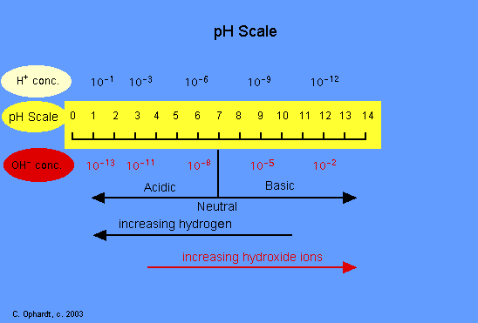
Biologists use the pH scale to describe whether a solution is acidic or basic
- .
- .

What are Buffers? And why do we use them?
- Buffers -
  - Most buffers consist of an acid-base pair that reversibly combines with H⁺
  - The internal pH of most living cells must remain close to pH 7
How does Acidification Threaten Water Quality?
  - .

.

- As seawater acidifies, carbonate ions are converted into bicarbonate
- Marine organisms need Carbonate calcification (production of calcium carbonate)
  - reef-building corals, marine organisms with shells
What about the good ole’ Acid Rain?
- The burning of fossil fuels is also a major source of sulfur oxides and nitrogen oxides
  - These react with water in the air to form strong acids that fall in rain or snow
  - Acid precipitation is rain, fog, or snow with a pH lower than 5.2
- Acid precipitation damages life in lakes and streams and changes soil chemistry on land

