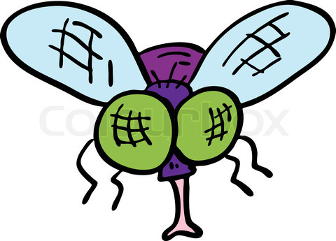
Virtual Fly Lab
An Investigation into Fruit Fly Genetics

Name: __________________________________________

Overview:
Fruit flies—the genetic whipping boy. Fly genetics are a huge part of the field, the tiny little Drosophila melanogaster providing aspiring geneticists with over a century of good times. And flies are also a royal pain in the butt to work with, especially if you’re new at it. So let’s use the benefits of the modern age and perform our fly lab squarely within the boundaries of cyberspace. Ready? Good. Let’s go.

Directions:

1. Sign in and log on to your computer. Open the internet browser and go to the following website:
http://www.sciencecourseware.org/vcise/drosophila/
2. Click the “”Enter as a Guest” option.
3. And here we are in our virtual lab. One very important thing:
DO NOT BACK OUT OF THIS PAGE UNTIL YOU ARE COMPLETELY DONE!!!
Or you will have to start over.
4. The first order of business: you will need to order your fruit flies. Click on the computer and use the “Order Flies” icon. We are going to perform three different crosses. For each one, you will need to order the correct flies. Start with Cross 1 and work your way through.

Cross 1: Cross a sepia eyed male with a wild type (red eyed) female.
Cross 2: Cross a sepia eyed, normal wing male with a wild type eyes, vestigial wing female.
Cross 3: Cross a wild type male with a white eyed female.
5. After ordering your flies, you will have to work through the lab until you eventually have sorted your F1 progeny. Make sure you record all of the necessary data in your data table (phenotypes/# of males/females).

6. After you have recorded the data, you will need to establish a cross between members of your F1 generation. To do this, click on the piles of sorted flies to zoom in. Then click the “Use in New Mating” button. Do this for both a male and a female. Then return to your lab. Click on the mating jar.

7. Sort your progeny and record the necessary data in the F2 data table.

8. After you collect F2 data, clean out your incubator by clicking on the small trash can next to it. This resets your lab for the next cross.

9. Now that you have the F2 data, you can begin to formulate some conclusions about the mode of inheritance for the traits you are looking at. Briefly comment on what you believe the mode of inheritance to be. You will address the following points in your assessment/conclusion:

a. What is the approximate phenotypic ratio shown in the F2 generation?
b. Does the gender of the flies seem to affect the inheritance of the traits in the cross?
c. Propose a hypothetical mode of inheritance for your given traits.

10. Chi- Square Analysis

Directions: Using a Chi-Square test, determine whether or not the variation between the observed and expected number of individuals of each phenotype can adequately be explained by chance alone. Use the following formula and apply it to the chi-square table to determine the confidence level for the hypothesis that the variation you observed is due solely to chance. The table of probabilities is provided below the formula.
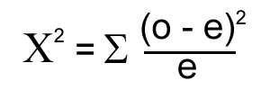

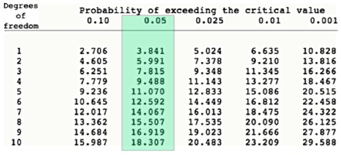

Remember, any probability greater than .05 is not unlikely enough to disprove your hypothesis.

10. Congratulations! You have completed Cross 1! The only thing left to do is your other two crosses. To order new flies, simply click on the computer and repeat.

11. When you have completed all of the crosses, you may move on to the analysis section of the lab.

12. I’m proud of you. Really, I am.

Cross 1: P= sepia male * wild type female
Table 1- Phenotypes of the F1 Generation
Phenotype | Number of Males | Number of Females

Table 2- Phenotypes of the F2 Generation
Phenotype | Number of Males | Number of Females
Assessment/Conclusion:
1. Describe the parental cross you performed, using genetic symbols.

2. Draw a Punnett square to show the possible allelic combinations for this gene in the F1 generation. You do not need to keep track of gender unless you believe it is a factor in this cross.

3. Identify the genotype ratio the F1 flies should exhibit. Identify the phenotype ratio.

Genotype Ratio: Phenotype Ratio:

4. Describe the F1 cross you performed and draw a Punnett square to show the possible allelic combinations in the F2 generation.

5. Identify the genotype ratio the F2 flies should exhibit. Identify the phenotype ratio. Compare your results to the predicted ratios.

Genotype Ratio: Phenotype Ratio:

6. Identify the cross you performed as the following: Monohybrid or Dihybrid, Autosomal or Sex-linked, Dominant or Recessive mutations. Justify your conclusion.

7. Chi- Square Analysis

Hypothesis for Mode of Inheritance:______________________________________

Observed | Expected | O - E | (O - E)²/E

Degrees of Freedom: _________ X² = ___________

P Value: __________

Accept or Reject Null Hypothesis: ________________________

Cross 2: P= sepia-eye, normal-wing male * wild type, vestigial wing female
Table 1- Phenotypes of the F1 Generation
Phenotype | Number of Males | Number of Females

Table 2- Phenotypes of the F2 Generation
Phenotype | Number of Males | Number of Females

Assessment/Conclusion:
1. Describe the parental cross you performed, using genetic symbols.

2. Draw a Punnett square to show the possible allelic combinations for this gene in the F1 generation. You do not need to keep track of gender unless you believe it is a factor in this cross.

3. Identify the genotype ratio the F1 flies should exhibit. Identify the phenotype ratio.

Genotype Ratio: Phenotype Ratio:

4. Describe the F1 cross you performed and draw a Punnett square to show the possible allelic combinations in the F2 generation.

5. Identify the genotype ratio the F2 flies should exhibit. Identify the phenotype ratio. Compare your results to the predicted ratios.

Genotype Ratio: Phenotype Ratio:

6. Identify the cross you performed as the following: Monohybrid or Dihybrid, Autosomal or Sex-linked, Dominant or Recessive mutations. Justify your conclusion.

7. Chi- Square Analysis

Hypothesis for Mode of Inheritance:______________________________________

Observed | Expected | O - E | (O - E)²/E

Degrees of Freedom: _________ X² = ___________

P Value: __________

Accept or Reject Null Hypothesis: ________________________

Cross 3: P= wild type male * white eyed female
Table 1- Phenotypes of the F1 Generation
Phenotype | Number of Males | Number of Females

Table 2- Phenotypes of the F2 Generation
Phenotype | Number of Males | Number of Females

Assessment/Conclusion:
1. Describe the parental cross you performed, using genetic symbols.

2. Draw a Punnett square to show the possible allelic combinations for this gene in the F1 generation. You do not need to keep track of gender unless you believe it is a factor in this cross.

3. Identify the genotype ratio the F1 flies should exhibit. Identify the phenotype ratio.

Genotype Ratio: Phenotype Ratio:

4. Describe the F1 cross you performed and draw a Punnett square to show the possible allelic combinations in the F2 generation.

5. Identify the genotype ratio the F2 flies should exhibit. Identify the phenotype ratio. Compare your results to the predicted ratios.

Genotype Ratio: Phenotype Ratio:

6. Identify the cross you performed as the following: Monohybrid or Dihybrid, Autosomal or Sex-linked, Dominant or Recessive mutations. Justify your conclusion.

7. Chi- Square Analysis

Hypothesis for Mode of Inheritance:______________________________________

Observed | Expected | O - E | (O - E)²/E

Degrees of Freedom: _________ X² = ___________

P Value: __________

Accept or Reject Null Hypothesis: ________________________

