Name Date:
Directions: Calculate the Mean, Variance, and Standard Deviation for each Sample. Show all of your work to the right side of the problem!

Standard Deviation
The Standard Deviation is a measure of how spread out numbers are.
Its symbol is often σ (the greek letter sigma)
The formula is easy: it is the square root of the Variance. So now you ask, "What is the Variance?"

Variance
The Variance is defined as: The average of the squared differences from the Mean.
To calculate the variance follow these steps:
- Work out the Mean (the simple average of the numbers)
- Then for each number: subtract the Mean and square the result (the squared difference).
- Then work out the average of those squared differences.

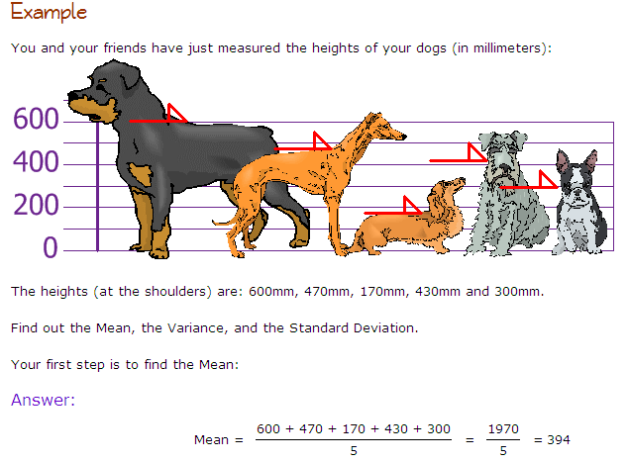

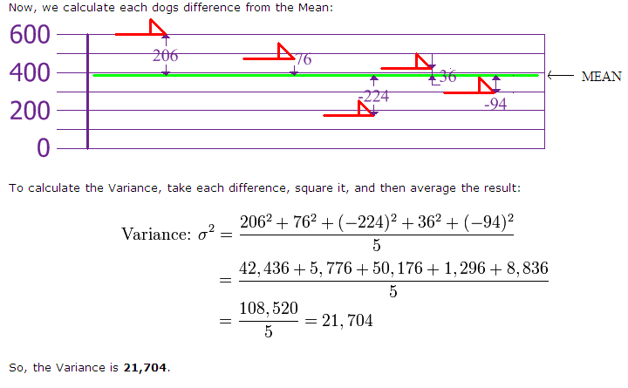
1) | PRACTICE PROBLEMS:  [5, 2, 1, 9]  Mean =  Variance =  Standard Deviation from Variance =
2) | [6, 1, 3, 7, 4]  Mean =  Variance =  Standard Deviation from Variance =
3) | [2, 5, 7, 5, 1]  Mean =  Variance =  Standard Deviation from Variance =
4) | [9, 2, 7, 2, 6]  Mean =  Variance =  Standard Deviation from Variance =
5) | [6, 8, 6, 3, 4]  Mean =  Variance =  Standard Deviation from Variance =
6) | [6, 6, 9, 9, 6, 1]  Mean =  Variance =  Standard Deviation from Variance =
7) | [4, 8, 9, 7, 6, 7]  Mean =  Variance =  Standard Deviation from Variance =
8) | [2, 6, 2, 4, 3, 1]  Mean =  Variance =  Standard Deviation from Variance =

9) What is Standard Deviation? Why would we bother calculating it?

