Protein Synthesis Model Lab
AP Biology

DNA is the molecule that stores the genetic information in your cells. That information is coded in the four bases of DNA: C (cytosine), G (guanine), A (adenine), and T (thymine). The DNA directs the functions of the cell on a daily basis and will also be used to pass on the genetic information to the next generation. Because of its critical role in all the functions of the cell, DNA is kept protected in the nucleus of your cells. DNA is organized in sections called genes. Genes code for proteins, and it is proteins that do all the work in the cell. They function as structural proteins — serving as the building blocks of cells and bodies. And they function as enzymes — directing all the chemical reactions in living organisms.
Proteins are made in the cytoplasm by ribosomes. Since DNA cannot leave the nucleus, the
information from DNA must be transmitted from the nucleus to the cytoplasm. During transcription, each gene on the DNA is read and codes directly for a messenger RNA (mRNA) molecule. The mRNA is made by matching its complementary bases — C, G, A, and U (uracil) — to the DNA bases. This process is called transcription, because the message is going from one version of nucleic acid language (DNA code) to another version of nucleic acid language (RNA code), so it is like transcribing from the key of G to the key of C in music. Before leaving the nucleus, this primary mRNA transcript is modified in several ways. Introns (intervening non-coding units) are edited out and exons (expressed coding sequences) are spliced together. In addition, a 5ʹ′ GTP cap and a 3ʹ′ poly-A tail are added to the mRNA to protect it from RNase enzymes in the cytoplasm. This mature mRNA transcript then leaves the nucleus and carries the code for making the protein from the DNA gene in the nucleus to the ribosome in the cytoplasm.
During translation, the ribosome reads the sequence of bases on the mRNA in sets of three —
the triplet codons. Another type of RNA — transfer RNA (tRNA) — brings the protein building
blocks — amino acids — to the ribosome as they are needed. The ribosome bonds the amino
acids together to build the protein coded for by the gene back in the nucleus. This process is
called translation, because the message is going from nucleic acid language (DNA/RNA code)
to the completely different amino acid language (protein code), so it is like translating from
English to Chinese.

PROCEDURE
1. Obtain the paper with 4 sections of DNA. Cut the strips out along straight lines and tape them together to make a long one-sided DNA molecule. Each section is numbered. Lay them out on the desk from left (#1) to right (#4). See the diagram below. This will form one long strand of DNA and will serve as the template strand of our gene.
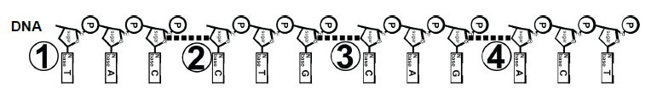

2. We are going to use this section of our DNA as a gene to be transcribed and then translated into a protein the cell needs. Remember it used to be part of a double-stranded DNA molecule. But it has already been unzipped and now will be used as the template to build mRNA, one base at a time. So first design an RNA polymerase enzyme to do this mRNA synthesis job.

3. You have also been supplied with mRNA nucleotides. Build an mRNA molecule, one base at a time, from this gene by transcribing your DNA template. Don’t forget to only start transcribing downstream from the TATA box promoter sequence. As you are transcribing, tape this mRNA molecule along its length to simulate the covalent bonds between bases. This way, it will be a stable molecule and can be moved off of the DNA to the ribosome for translation in the cytoplasm. Do not tape the mRNA to the DNA! Remember it has to leave the DNA in the nucleus and travel to the ribosome in the cytoplasm. Follow the diagram.
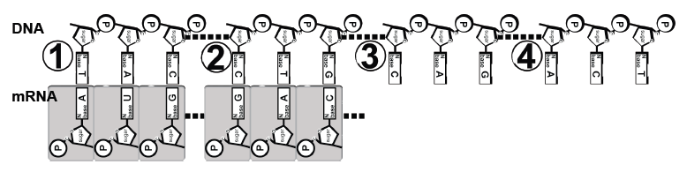
4. You have just made a primary transcript. It must be processed so it successfully travels to the ribosome in the cytoplasm. Although we will not be simulating intron and exon splicing in this lab, you do need to add a 5′ GTP cap and a 3ʹ poly-A tail to the mRNA to protect the mRNA. Although poly-A tails may be 20-100 bases long, add 6 adenine bases for your simulated poly-A tail.
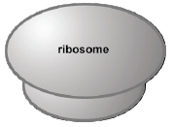
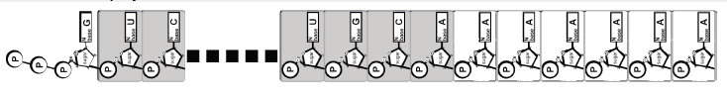

5. To be ready for the mRNA in the cytoplasm, design a ribosome to use in your simulation.

6. Next you need to build the polypeptide from the amino acids which are coded in the mRNA. Every 3 bases codes for one amino acid. The tRNA with a matching anticodon will deliver the correct amino acid to the growing chain. The tRNA molecule with the correct amino acid will have a complementary base sequence to the mRNA codon. Obtain the tRNA molecule papers and start translating at the START codon (AUG, which codes for Met). Make sure you are reading in the 5’ to 3’ direction of your mRNA strand (so start from the end with the GTP cap). Translate the mRNA into amino acids until you reach the STOP codon (UGA). Refer to the diagram below to help you.

7. Label the name of the amino acid that each tRNA is carrying. To help you with this, use the mRNA codon chart and the amino acid code chart supplied by your teacher. Start reading the mRNA at the START codon and end at the STOP codon. Follow the diagram below.
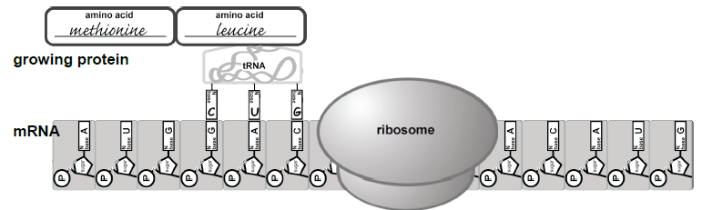
aspartic acid

8. In real protein synthesis, the tRNAs would detach from the amino acids leaving just a string of amino acids, otherwise referred to as a polypeptide. Use your DNA, your mRNA, and your polypeptide to answer the Summary Questions.

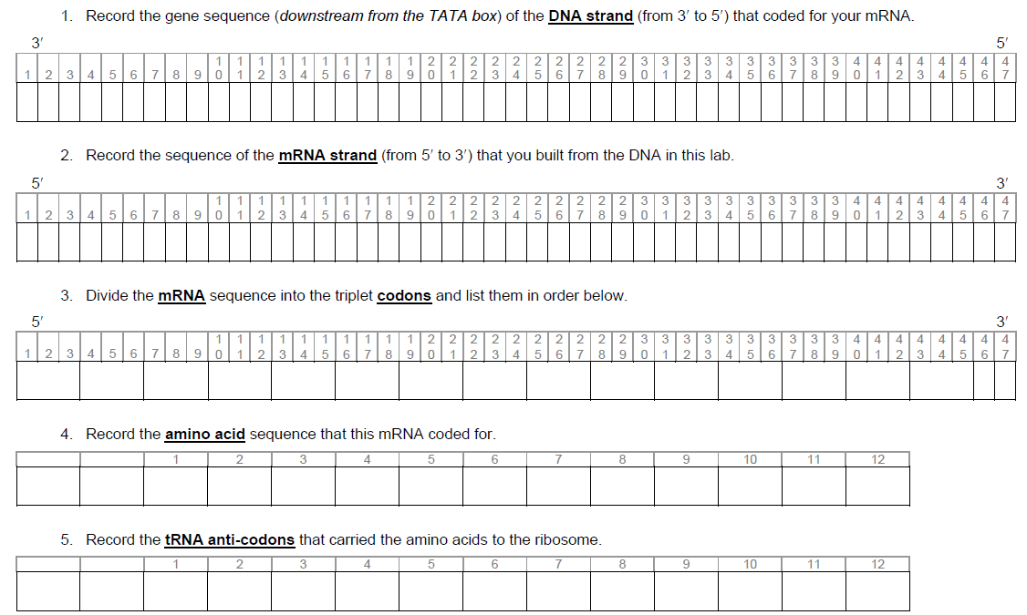

Name: ________________________________
MUTATIONS
Sometimes when DNA is copied (replicated) errors occur. We call these mutations. When these mutations occur in gametes, they have the potential of being passed on to offspring and therefore will affect the next generation. Sometimes mutations cause only minor changes to a gene and therefore make only minor changes in the protein produced from that gene. These types of mutations may cause only minor effects to the phenotype of an organism. But sometimes mutations can cause great changes to the gene and therefore greatly alter the protein that is made from that gene. This will likely have great effects on the organism, since the protein will not be able to perform its normal function. This may lead to the inheritance of a genetic disease.
There are several types of mutation:
- DELETION (a base is lost/deleted)
- INSERTION (an extra base is added/inserted)
--- Deletion & insertion may cause what’s called a FRAMESHIFT mutation, meaning the reading “frame" changes, thus changing the amino acid sequence from this point forward
- SUBSTITUTION (one base is substituted for another)
--- If a substitution changes the amino acid, it’s called a MISSENSE mutation
--- If a substitution does not change the amino acid, it’s called a SILENT mutation
--- If a substitution changes the amino acid to a “stop,” it’s called a NONSENSE mutation
Complete the boxes below. Classify each as Deletion, Insertion or Substitution AND as either
frameshift, missense, silent or nonsense (Hint: Deletion & Insertion will always be frameshift).

Original DNA Sequence: T A C A C C T T G G C G A C G A C T …
mRNA Sequence:
Amino Acid Sequence: __________________________________________________

Mutated DNA Sequence #1 T A C A T C T T G G C G A C G A C T …
What’s the mRNA sequence? (Circle the change)
amino acid sequence?
Will there likely be effects? What type of mutation is this? ___________________________

Mutated DNA Sequence #2 T A C G A C C T T G G C G A C G A C T …
What’s the mRNA sequence? (Circle the change)
amino acid sequence?
Will there likely be effects? What type of mutation is this? _____________________________

Mutated DNA Sequence #3 T A C A C C T T A G C G A C G A C T …
What’s the mRNA sequence? (Circle the change)
amino acid sequence?
Will there likely be effects? What type of mutation is this? _______________________

Mutated DNA Sequence #4 T A C A C C T T G G C G A C T A C T …
What’s the mRNA sequence? (Circle the change)
amino acid sequence?
Will there likely be effects? What type of mutation is this? _________________________

Mutated DNA Sequence #5 T A C A C C T T G G G A C G A C T …
What’s the mRNA sequence? (Circle the change)
What will be the amino acid sequence?
Will there likely be effects? What type of mutation is this? _______________________

- Which type of mutation is responsible for new variations of a trait?
- Which type of mutation does not result in an abnormal amino acid sequence?
- Which type of mutation stops the translation of an mRNA molecule? __________________________
- Why could a mutation in a gamete have more profound biological consequences than a mutation in a somatic cell?

_______________________________________________________________________
- Which type of mutations seem to have the largest effect? _______________________

- Sickle Cell Anemia
Sickle cell anemia is the result of a type of mutation in the gene that codes for part of the hemoglobin molecule. Hemoglobin carries oxygen in your red bloods cells. The mutation causes these red blood cells to become stiff & sickle-shaped when they release their oxygen. The sickled cells tend to get stuck in blood vessels, causing pain and increased risk of stroke, blindness, damage to the heart & lungs, and other conditions.
Analyze the DNA strands below to determine what amino acid is changed AND what type of mutation occurred

Normal hemoglobin DNA C A C G T A G A C T G A G G A C T C …
Normal hemoglobin mRNA _______________________________________
Normal hemoglobin AA sequence _______________________________________
Sickle cell hemoglobin DNA C A C G T A G A C T G A G G A C A C …
Sickle cell hemoglobin mRNA _______________________________________
Sickle cell hemoglobin AA sequence _______________________________________

- Describe the specific DNA changes that produce the abnormal sickle cell hemoglobin

_______________________________________________________________________

- Explain the structural effect that this point mutation has on the hemoglobin protein

_______________________________________________________________________

- Sickle Cell heterozygotes are selected for in regions of the world where there is a high instance of malaria. This is called heterozygote advantage. Explain why the sickle cell mutation is selected for in these areas of the world.

_______________________________________________________________________
10. Cystic fibrosis is an example of a genetic disease caused by a frameshift mutation in the delta508 gene. What is the outcome of the protein’s ability to function knowing this piece of information.

_______________________________________________________________________
11. Are mutations always deleterious? What is the evolutionary value of mutations? Explain.

_______________________________________________________________________________________________________________________________________________________________________________________________________________________________________________________________________________________________________
12. Assume that a particular genetic condition in a mammalian species causes an inability to digest starch. This disorder occurs with equal frequency in males and females. In most cases, neither parent of affected offspring has the condition. Explain how a mutation could cause this inability to digest starch.
_________________________________________________________________________________________________________________________________________________________________________________
13. In the protein synthesis model building part of the lab, there was a very important step left out of the process of making a protein from a sequence of DNA. Can you identify what that was?
_________________________________________________________________________________________

