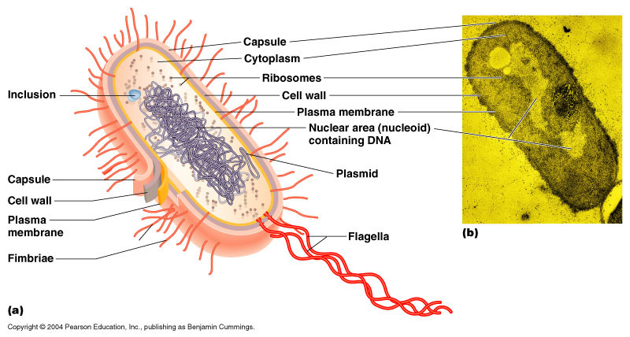
Prokaryotic
Gene Regulation
Why Regulate Genes?
- __________________________________
- gene expression is affected by changes in the external environment
- __________________________________
- All cells have the full set of genes, but not all genes are needed in each cell (some are turned off)

Bacteria need to respond quickly to changes in their environment
Bacterial metabolism
If they have enough of a product, ________________________________
Why?

How?

If they find a new food/energy source… ______________________________________
Why?

How?

Natural selection favors cells that can do this well because it’s COST EFFECTIVE
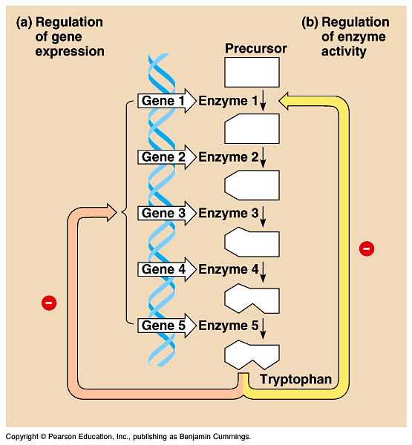
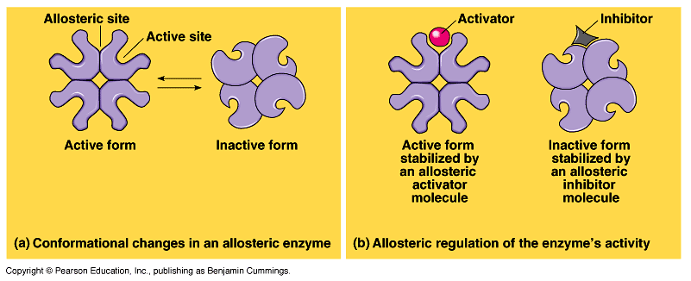
Enzyme Review

Feedback Inhibition

- but this is wasteful production of enzymes

Different way to Regulate Metabolism Gene Regulation!!!
- Why is this good?

Overview of Gene Regulation in Prokaryotes:

On and Off. Off and On. On and Off.
Turn genes OFF example

Turn genes ON example

Operon Structure
1.
- example: all enzymes in a metabolic pathway
2.
- single promoter controls transcription of all genes in operon
- transcribed as one unit & a single mRNA is made
3.

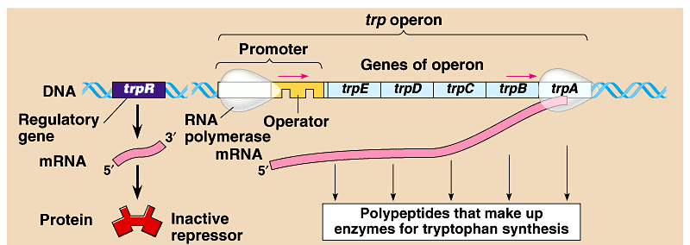

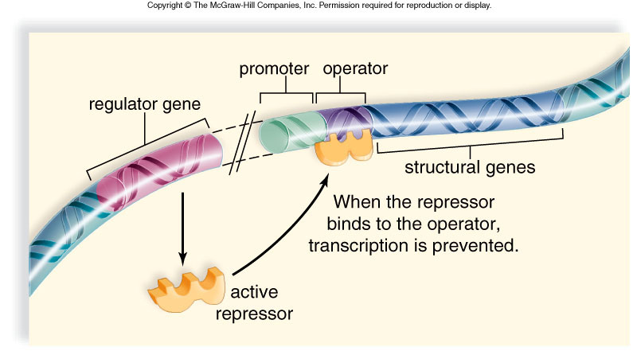
So how can these genes be turned off?

Operon Model:
operator, promoter & genes they control serve as a model for gene regulation

Two Main Types of Operons:
Repressible (_________________________) -

Inducible (________________________) -

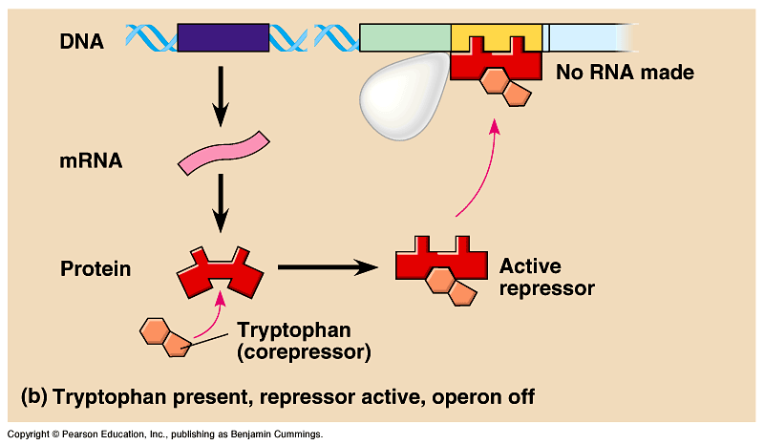
Synthesis Pathway Model (__________________________)

Tryptophan is allosteric regulator of repressor protein

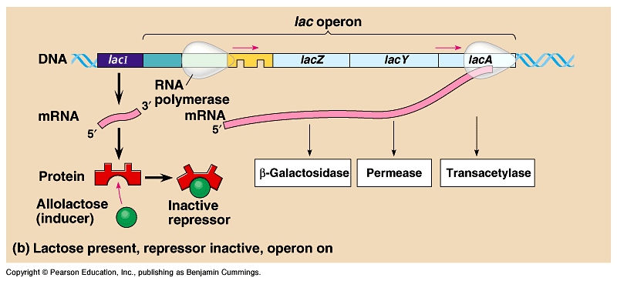
Digestive Pathway Model (___________________________________)

Lactose is allosteric regulator of repressor protein
Operon Summary
Repressible Operon Inducible Operon

More to the Story… Negative vs. Positive Reg.
negative regulation
  - repressor protein binds to the operator, turns off transcription

positive regulation
  - activator binds to the promoter, turns transcription up (amplifies expression)

Prokaryotic vs Eukaryotic Transcriptional Control

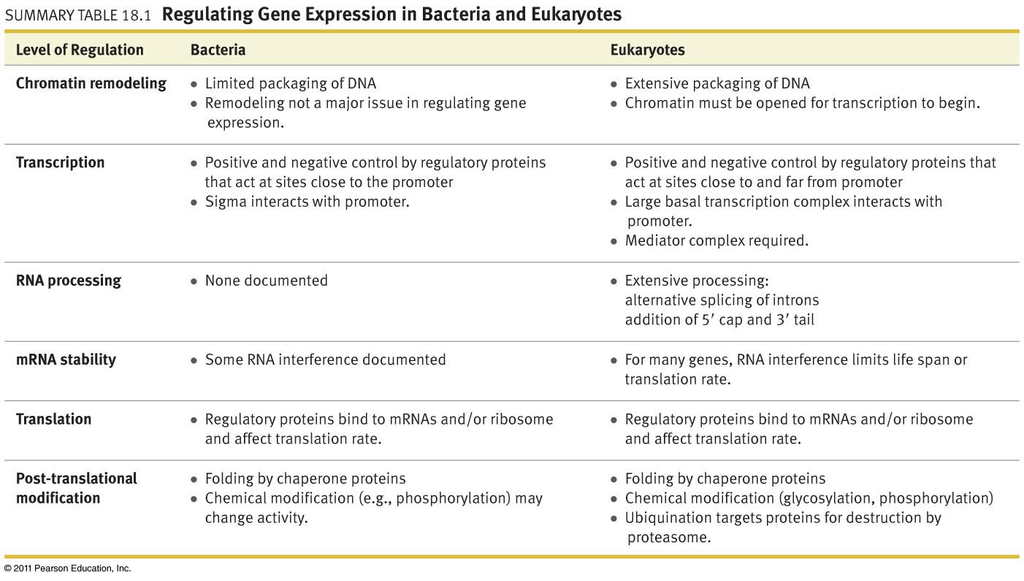

RNA
an amazing little thing
Coding RNA =
Non-coding RNA =

RNA Interference involves siRNA and microRNA
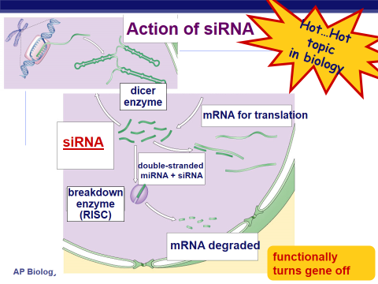
siRNA = Small Interfering RNA

microRNA

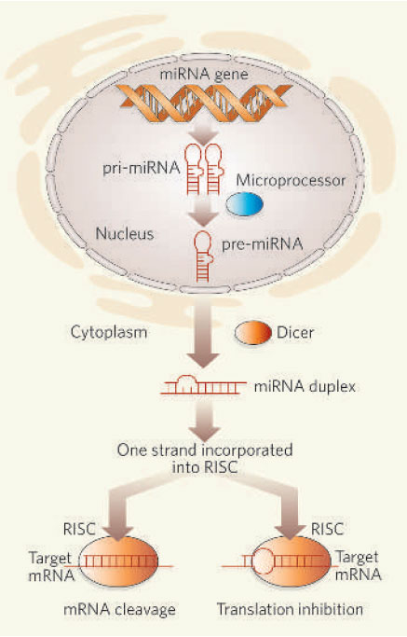

Applications of microRNAs

