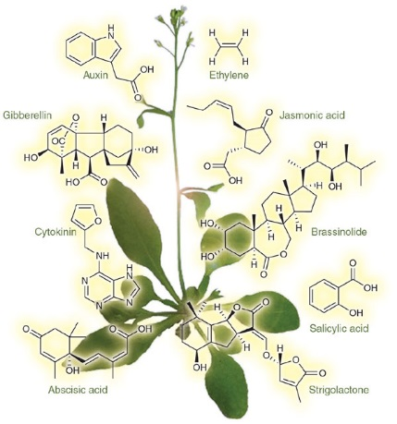
Plant Responses to
External and Internal Signals
How do plants respond to the environment?
How do plants respond to internal signals?

Plants have Hormones!
Hormones = long distance signaling molecules, coordinate the various parts of an organism

5 Major Classes of Plant Hormones – Each has a specific function
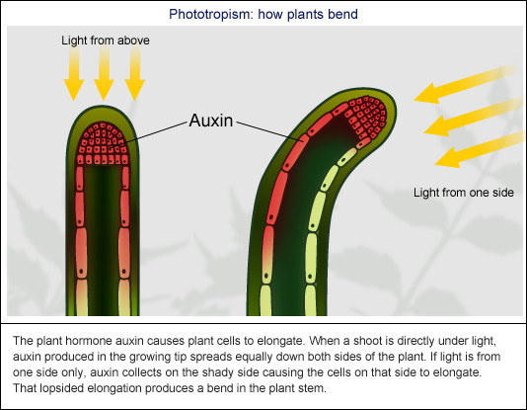

1.Auxins

2.Cytokinins
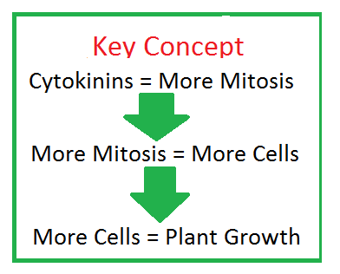

3.Gibberelins

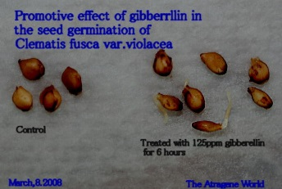

4.Ethylene

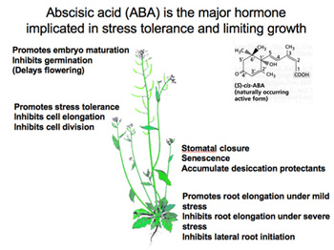

5.Abscisic Acid

Plants also have specific GROWTH responses

Tropisms =

3 Major Stimuli that induce tropisms:
- Light (_____________________)
- Gravity (__________________________)
- Touch (________________________)
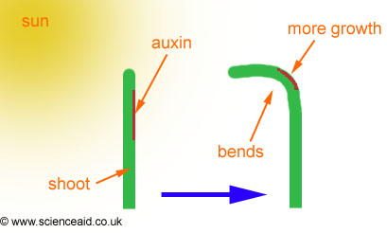
Phototropism

- Primarily due to _______________
- Auxin elongates on the ________________ side

- Plants and light LOVE each other

  - Phototropism

  - Photoperiodism

    - Circadian Rhythms

Even without external, environmental cues, circadian rhythms persist in humans and in all eukaryotes (yes, plants!)
Photoperiodism

It’s actually the NIGHT that matters
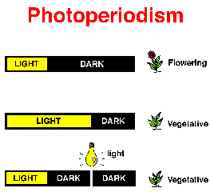
Short, Long, and Neutral Plants
  - Short-day plants
    - Require a shorter light period
    - Flower in later summer/fall/winter
    - Example: poinsettias
  - Long-day plants
    - Require a longer light period
    - Flower in late spring/early summer
    - Example: spinach
  - Day-neutral plants
    - Are unaffected by photoperiod
    - Example: tomatoes

Gravitropism
- Roots demonstrate _______________ gravitropism
- Shoots exhibit _______________ gravitropism.
- _______________ play a major role

Ensures that the root grows in the soil and that the shoot reaches sunlight regardless of how a seed happens to be oriented when it lands.
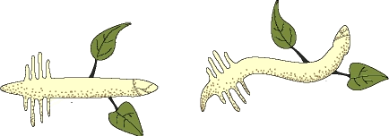

Plant Defenses
- a plant generally responds to environmental cues by adjusting its pattern of growth and development.
- At the cellular level, plants and all other eukaryotes are surprisingly similar in their signaling mechanisms.

Plants have Cellular Receptors – used to detect changes in their environment
- Changes may be:

Example: Etiolation – growth response to _______________
  - Seedlings germinate in dark and grow underground
  - Once a shoot reaches the sunlight, morphology and biochemistry undergo changes, collectively called de-etiolation, or greening

Defenses Against Herbivores
Physical -
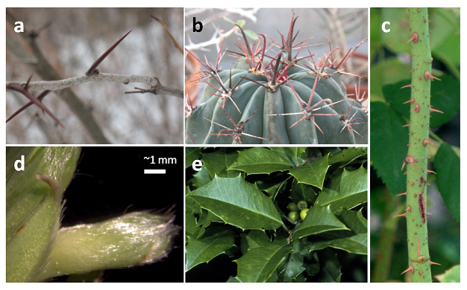
Chemical -

