What factors affect the rate of photosynthesis in living leaves?

Name: __________________________ Date: __________
Photosynthesis Investigation(s) (based on Investigation 5, AP Biology Investigative Labs)
Big Idea 2: Cellular Processes: Energy and Communication

Background: Living systems require free energy and matter to maintain order, to grow, and to reproduce. Energy deficiencies are not only detrimental to individual organisms, but they cause disruptions at the population and ecosystem levels. Organisms employ various strategies that have been conserved through evolution to capture, use, and store free energy. Autotrophic organisms capture free energy from the environment through photosynthesis and chemosynthesis, whereas heterotrophic organisms harvest free energy from carbon compounds produced by other organisms. In multicellular plants, photosynthesis occurs in the chloroplasts within cells.

The process of photosynthesis occurs in a series of enzyme-mediated steps that capture light energy to build energy-rich carbohydrates. The process is summarized by the following reaction:

2 H2O + CO2 + light → carbohydrate (CH2O) + O2 + H2O

To determine the net rate of photosynthesis, one could measure one of the following:
- Production of O2
- Consumption of CO2

The difficulty related to measuring the production of oxygen is compounded by the complementary process of aerobic respiration consuming oxygen as it is produced. Therefore, measuring oxygen production is equivalent to measuring net photosynthesis. A measurement of respiration in the same system allows one also to estimate the gross production.

Light is a part of a continuum of radiation, or energy waves. Shorter wavelengths of energy have greater amounts of energy. For example, high-energy ultraviolet rays, with wavelengths of approximately 1 nanometer (nm) to 380 nm, can harm living tissues due to the large amount of energy they carry. Wavelengths of light within the visible part of the light spectrum power photosynthesis. The visible light spectrum is from about 400 to 750 nm (1 billionth of a meter). Only visible light, with its intermediate wavelengths, has enough energy to cause chemical change without destroying biological molecules. The short, high frequency waves of gamma rays (10-5 nm) have too much energy and break the hydrogen bonds found within biological molecules such as proteins and nucleic acids like DNA. The longer waves of heat, microwaves and radio waves (103 nm to 103 meters) do not possess enough energy and are absorbed by the water molecules in a plant.

When light is absorbed by leaf pigments, such as chlorophyll a or b, electrons within each Photosystem are boosted to a higher energy level. This energy is used to produce ATP, to reduce NADP to NADPH and then used to incorporate carbon dioxide (CO2) into organic molecules in a process called carbon fixation. Leaf disks float, normally. When the air spaces are infiltrated with a solution the overall density of the leaf disk increases and the disk sinks. The infiltration solution includes a small amount of sodium bicarbonate (NaHCO3) thus enabling the bicarbonate ion to serve as the carbon source for photosynthesis. As photosynthesis proceeds, oxygen is released into the interior of the leaf which changes its buoyancy causing the disks to rise. Since cellular respiration is taking place at the same time within the leaf, consuming the oxygen generated by photosynthesis, the rate that the disks rise is an indirect measurement of the net rate of photosynthesis. In this lab, you will measure the net rate of photosynthesis for several plants under various lighting conditions.
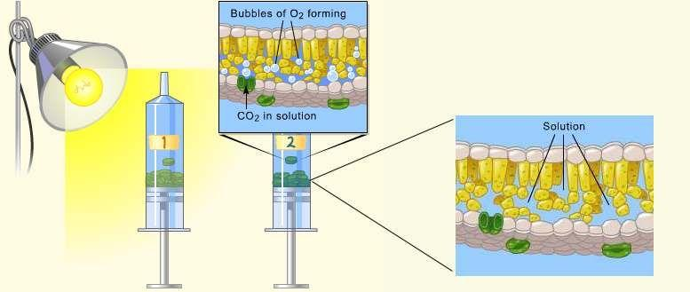

Photosynthesis Investigation #1-Baseline
In this investigation you will determine the rate of photosynthesis in spinach plants using a method known as the “floating leaf disk assay.” Watch the Photosynthesis Lab Video @ http://www.youtube.com/watch?v=6Z-SpXUeKr0 to help you understand what you will do. After establishing this data as a baseline, you will be able to vary a number of conditions and therefore study how other factors affect photosynthetic rate.

Materials: leaf samples (i.e. spinach, ivy, pokeweed), sodium bicarbonate (baking soda), liquid soap, plastic syringe (10 cc or larger), clear, plastic cups, timer, light source, hole punch, 2 small beakers, 10ml plastic disposable pipette, metric ruler

Procedure: You will all run a set of leaf disks in sodium bicarbonate and one in water at room temperature as a baseline and then you will be able to run a second set investigating some “other” condition(s).

- Label cups with the following: 30 cm CO2 Light & Water Light.
- Make 1L of a 0.2% Sodium Bicarbonate Solution

SHOW YOUR CALCULATIONS AND DRAW A DIAGRAM OF HOW TO PREP THIS SOLUTION BELOW
CALCULATIONS DIAGRAM

Figure 1
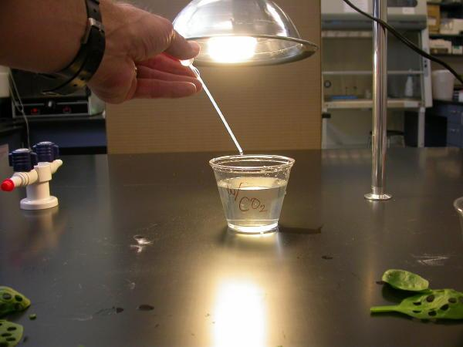

- Add a drop or two of soap to your sodium bicarbonate solution and mix (AVOID SUDS). (Fig. 1)

- Using a hole punch or other device, punch 10 uniform leaf disks for each trial. Avoid the major veins in the leaf (Fig. 2)
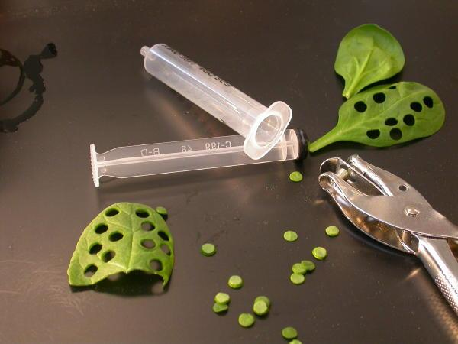

Figure 2
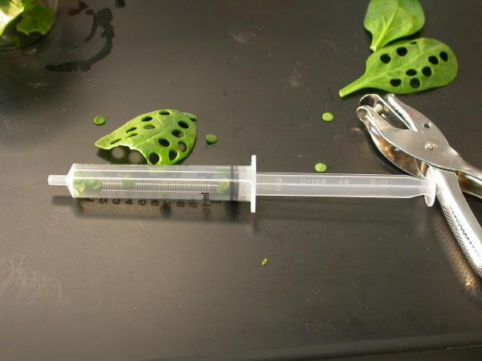

- Remove the plunger of the syringe and place your leaf disks in the syringe barrel.
- Replace the plunger, being careful not to crush the leaf disks. Push on the plunger until only a small volume of air and leaf disk remain in the barrel. (Fig. 3)

Figure 3
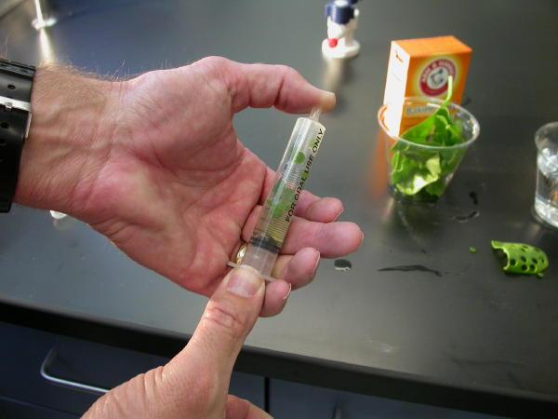
- Put a small volume of sodium bicarbonate solution into the syringe. Tap the syringe to suspend the leaf disks in the solution.
- Hold a finger over the syringe opening, draw back on the plunger to create a vacuum. Hold this for 10 seconds.
- While holding the vacuum, swirl the leaf disks to suspend them in solution. Let off the vacuum. (Fig. 4)
- If you need to, repeat the
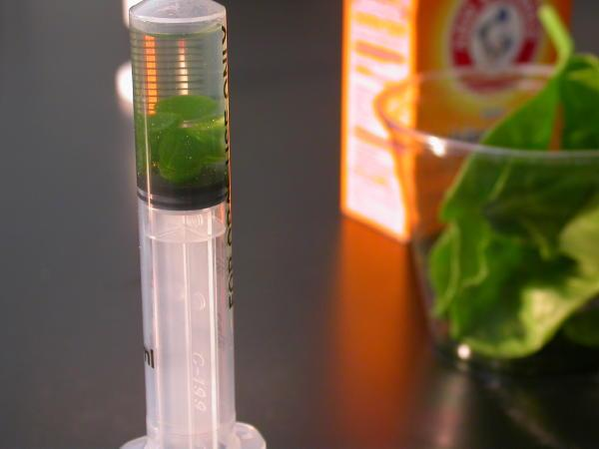
vacuum steps 2-3 times more,
until the entire disks sink.
(Fig. 5)

Figure 5

- If the disks still don’t sink, add more soap to the solution and repeat steps 8-10.
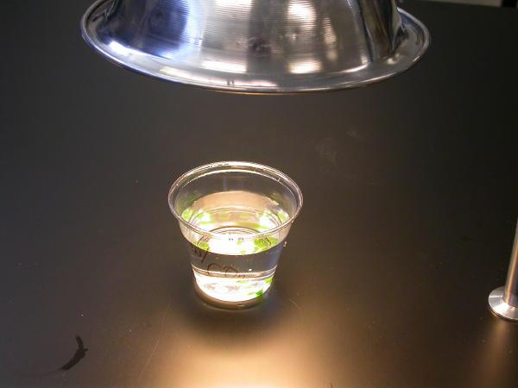
- Pour the disks and the solution into the correct cup.
- Add approximately 200mL of the bicarbonate solution until the cup is 3/4 full.
- Place under light that is located about 30 cm away and begin timing (Fig. 6).

Figure 6
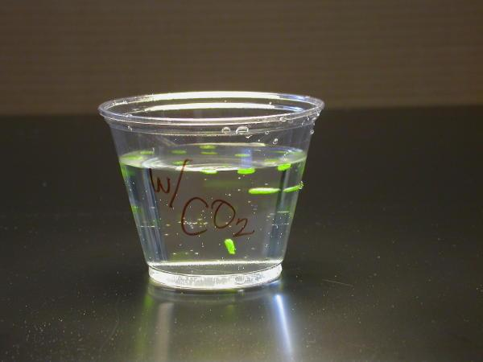
- Record the number of disks that are floating at the end of each minute in the table below.
- Then gently swirl the disks with the pipette to dislodge any that are stuck to each other or the sides of the cup.
- Repeat step 17 until ALL of the disks are floating. (Fig. 7)

Figure 7

- Repeat the above steps with “Water/Light” set-up but replace the bicarbonate solution with water (with one drop of soap).

- Keep the cups under the light for at least 15 minutes, counting the disks every minute. At 15 minutes, shut off the light and place the disks in the dark.

- Every minute, count how many disks are still floating until all the disks have sunk or you have reached 30 minutes

- Gently swirl the disks with the pipette to be certain all disks have been properly displaced.

DATA TABLES: 4 for your group’s data and 4 for the class data

Lab Group Data Table: # of Leaf Disks Floating Under Light Conditions at Room Temperature—CO2
LIGHT ON
 | Min 1 | Min  2 | Min 3 | Min 4 | Min 5 | Min 6 | Min 7 | Min 8 | Min 9 | Min 10 | Min 11 | Min 12 | Min 13 | Min 14 | Min 15
# of Leaf Disks Floating

Lab Group Data Table: # of Leaf Disks Floating Under Light Conditions at Room Temperature—CO2
LIGHT OFF
 | Min 16 | Min 17 | Min 18 | Min 19 | Min 20 | Min 21 | Min 22 | Min 23 | Min 24 | Min 25 | Min 26 | Min 27 | Min 28 | Min 29 | Min 30
# of Leaf Disks Floating

Lab Group Data Table: # of Leaf Disks Floating Under Light Conditions at Room Temperature-WATER
LIGHT ON
 | Min 1 | Min  2 | Min 3 | Min 4 | Min 5 | Min 6 | Min 7 | Min 8 | Min 9 | Min 10 | Min 11 | Min 12 | Min 13 | Min 14 | Min 15
# of Leaf Disks Floating

Lab Group Data Table: # of Leaf Disks Floating Under Light Conditions at Room Temperature--WATER
LIGHT OFF
 | Min 16 | Min 17 | Min 18 | Min 19 | Min 20 | Min 21 | Min 22 | Min 23 | Min 24 | Min 25 | Min 26 | Min 27 | Min 28 | Min 29 | Min 30
# of Leaf Disks Floating

Class Data:
Lab Group Data Table: # of Leaf Disks Floating Under Light Conditions at Room Temperature—CO2
LIGHT ON
 | Min 1 | Min  2 | Min 3 | Min 4 | Min 5 | Min 6 | Min 7 | Min 8 | Min 9 | Min 10 | Min 11 | Min 12 | Min 13 | Min 14 | Min 15
Average

Lab Group Data Table: # of Leaf Disks Floating Under Light Conditions at Room Temperature—CO2
LIGHT OFF – CLASS DATA
 | Min 16 | Min 17 | Min 18 | Min  19 | Min 20 | Min 21 | Min 22 | Min 23 | Min 24 | Min 25 | Min 26 | Min 27 | Min 28 | Min 29 | Min 30
Average

Lab Group Data Table: # of Leaf Disks Floating Under Light Conditions at Room Temperature—WATER
LIGHT ON – CLASS DATA
 | Min 1 | Min  2 | Min 3 | Min 4 | Min 5 | Min 6 | Min 7 | Min 8 | Min 9 | Min 10 | Min 11 | Min 12 | Min 13 | Min 14 | Min 15
Average
Lab Group Data Table: # of Leaf Disks Floating Under Light Conditions at Room Temperature--WATER
LIGHT OFF – CLASS DATA
 | Min 16 | Min 17 | Min 18 | Min  19 | Min 20 | Min 21 | Min 22 | Min 23 | Min 24 | Min 25 | Min 26 | Min 27 | Min 28 | Min 29 | Min 30
Average

Analysis & Questions
- Graph the class averages for the CO2/Light and Water (include the Light On and Light Off data on the same graph). Give your graph a title and label your axes (with units).

- In the table below, calculate and record the rate of photosynthesis for each of the lines above for the Light ON condition only (so use data from 1 minute to 15 minutes ONLY!!!) (CO2/Light and Water/Light). Remember that the rate is determined by calculating the Δy/Δx. Show your calculations in the first column and the final rate in the last column.
Condition | Rate Calculations  (Rate = slope = ΔY/ ΔX) | Rate (# Leaf/Min)
CO2/Light
Water/Light
- Based on your graph, describe and explain the relationship between CO2 and photosynthesis.

Photosynthesis Investigations #2-Manipulating Variables

Name: _____________________________________ Date: _______
Now that you have an idea of how a “floating leaf disk assay” works and what the “baseline rate” for CO2/Light is, what would you like to change? Think about a variety of variables that you can change. List them in the space below.

Possible Variables to Change (Choose one of these to design your experiment below)

Independent Variable(s):______________________________

Dependent Variable(s):______________________________
How will they be measured? Be specific!!! What units?

Title:

Hypothesis:

Constants:

Procedure:

Steps Pictures

Lab Group Data Table: # of Leaf Disks Floating Under (____________________) Variable
LIGHT ON
 | Min 1 | Min  2 | Min 3 | Min 4 | Min 5 | Min 6 | Min 7 | Min 8 | Min 9 | Min 10 | Min 11 | Min 12 | Min 13 | Min 14 | Min 15
Trial #1
Trial #2

Lab Group Data Table: # of Leaf Disks Floating Under—(____________________) Variable
LIGHT OFF
 | Min 16 | Min 17 | Min 18 | Min 19 | Min 20 | Min 21 | Min 22 | Min 23 | Min 24 | Min 25 | Min 26 | Min 27 | Min 28 | Min 29 | Min 30
Trial #1
Trial #2

Analysis & Questions

- Graph the averages for the CO2/Light and Water (include the Light On and Light Off data on the same graph). Give your graph a title and label your axes (with units).

- In the table below, calculate and record the rate of photosynthesis for each of the lines above for the Light ON condition only (so use data from 1 minute to 15 minutes ONLY!!!) (CO2/Light and Water/Light). Remember that the rate is determined by calculating the Δy/Δx. Show your calculations in the first column and the final rate in the last column.
Condition | Rate Calculations  (Rate = slope = ΔY/ ΔX) | Rate (# Leaf/Min)
CO2/Light
Water/Light

- Compare these new rates with the rates you calculated in your baselines. Explain the effect this variable had on the rate of the reaction and whether this supported your hypothesis or not (Be sure to GIVE reaction rate data to support your statement).

- In the chart below, find out the reaction rate for at least two other groups. Have the group sign this data to verify that it is their work.

Condition | Group # | Rate (# Leaf/Min)
Variable:
Variable

- Compare these group’s rates with the rates you calculated in the baselines. Explain the effect these variables had on the rate of the reaction.

- EXPLAIN what caused the leaves to sink and what is causing the leaves to rise.

- What do we learn by shutting off the light and continuing to record the number of leaves floating? What is this a measure of?

