Cell Respiration Part 2 Free Response Practice Questions:
- 2015:
Cellular respiration includes the metabolic pathways of glycolysis, the Krebs cycle, and the electron transport chain, as represented in the figures. In cellular respiration, carbohydrates and other metabolites are oxidized, and the resulting energy-transfer reactions support the synthesis of ATP.
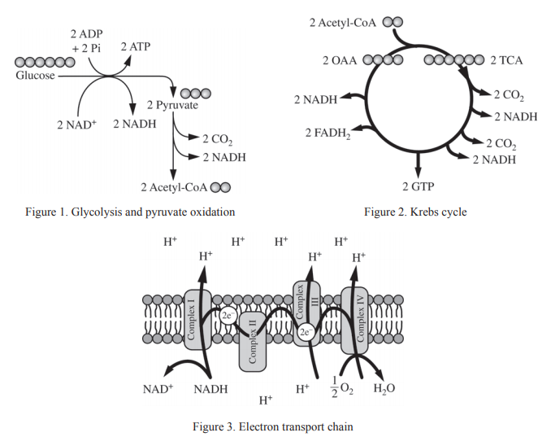

(a) Using the information above, describe ONE contribution of each of the following in ATP synthesis.
- Catabolism of glucose in glycolysis and pyruvate oxidation
- Oxidation of intermediates in the Krebs cycle
- Formation of a proton gradient by the electron transport chain

(b) Use each of the following observations to justify the claim that glycolysis first occurred in a common ancestor of all living organisms.
- Glycolysis occurs only in the cytosol.
- Nearly all existing organisms perform glycolysis.
- Glycolysis occurs under anaerobic conditions.

(c) A researcher estimates that, in a certain organism, the complete metabolism of glucose produces 30 molecules of ATP for each molecule of glucose. The energy released from the total oxidation of glucose under standard conditions is 686 kcal/mol. The energy released from the hydrolysis of ATP to ADP and inorganic phosphate under standard conditions is 7.3 kcal/mol. Calculate the amount of energy available from the hydrolysis of 30 moles of ATP. Calculate the efficiency of total ATP production from 1 mole of glucose in the organism. Describe what happens to the excess energy that is released from the metabolism of glucose.

(d) The enzymes of the Krebs cycle function in the cytosol of bacteria, but among eukaryotes the enzymes function mostly in the mitochondria. Pose a scientific question that connects the subcellular location of the enzymes in the Krebs cycle to the evolution of eukaryotes.

2. 2019
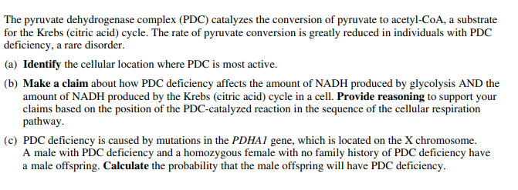

3. 2017:
