Molecular Genetics Review Sheet
Name: ______________________________________ Date: ________
Make a chart of the different scientists involved in the process of discovery of DNA and its structure.
Scientist | What was his/her experiment? | Conclusion
Griffith
Hershey and Chase
Watson and Crick
Chargaff
Meselsohn and Stahl
Franklin

Complete the chart to review the enzymes involved in DNA Replication and Protein Synthesis and their functions.
Enzyme | Function
Primase
DNA Polymerase III
helicase
ligase
DNA Polymerase I
RNA Polymerase
Aminoacyl Synthetase

Complete the chart to review the different molecular players in the Protein Synthesis process.
Molecular Identifier | Function
TATA Box
Promoter
Acetyl Group
Poly A Tail
Intron
Exon
Methyl Group
GTP

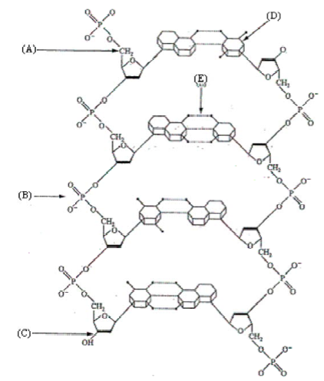
Label the following diagram of DNA. Include in your labels:
Phosphate, Deoxyribose, Purines,
Pyrimidines, 5’ and 3’ ends
Hydrogen Bonds

What are the 3 steps of Transcription, in order?

Complete the chart to review the 3 types of RNA and what are their functions?
RNA form | Function | Location
mRNA
tRNA
rRNA

How is RNA modified before it leaves the nucleus and why?

