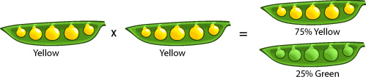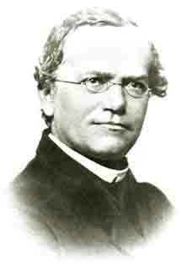**Mendel**

**and Heredity**

**Genetics is Like Drawing from the Deck of Genes.**

**The Blending hypothesis:**

**The Particulate hypothesis:**

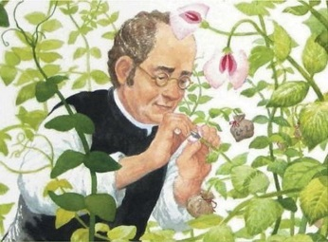

**Mendel used garden peas to investigate hereditary relationships. Why peas?**

**Mendel also used true-breeding plants.**

-true-breeding plant:

**Mendel’s Model**

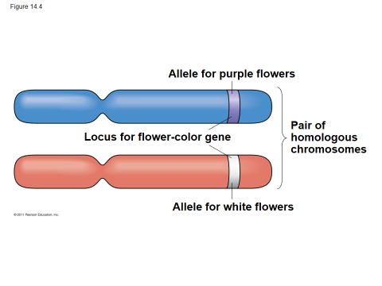Mendel noticed a ___________ (ratio) inheritance pattern in his breeding experiments in F2 offspring and developed a model to explain it

* **4 Concepts make up this Model 🡨**

1.

2.

3.

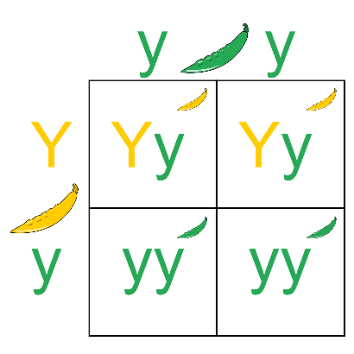

4.

**Punnett Squares:**

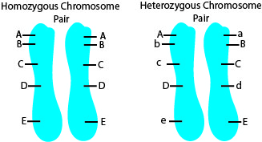***Useful Genetic Vocabulary:***

* **Homozygous =** two identical alleles for a gene (bb or BB)
* **Heterozygous =** two different alleles for a gene (Bb)
* **Heterozygotes** are **not** true-breeding
* **Homozygotes** are true-breeding
* **Phenotype =** physical appearance
* **Genotype** = genetic makeup

For example, in pea plants,

* + *PP* and *Pp* plants have the same **phenotype** (purple) but different **genotypes**

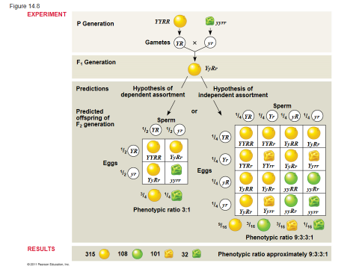

**The Test Cross =**

How is a Test Cross Performed?

**Law of Independent Assortment:**

What can a dihybrid cross show us about the genetics of the individuals?

* can determine whether two characters are transmitted to

offspring ***as a package*** or ***independently***

**Expected Phenotype Ratios for Hybrid Crosses:**

**Monohybrid: __________**

**Dihybrid: ______________**

**Probability is KING when it comes to Genetics**

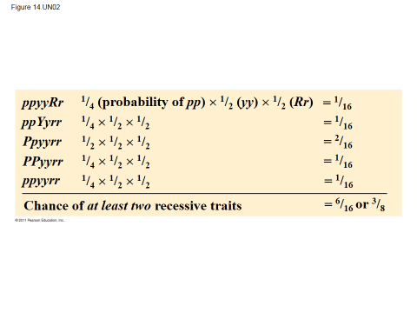

*Multiplication and Addition Rules of Probability:*

**Multiplication Rule:**

probability that two or more independent events will occur together is the **product** of their individual probabilities

**Addition Rule:**

probability that any one of two or more exclusive

events will occur is calculated by adding

together their individual probabilities

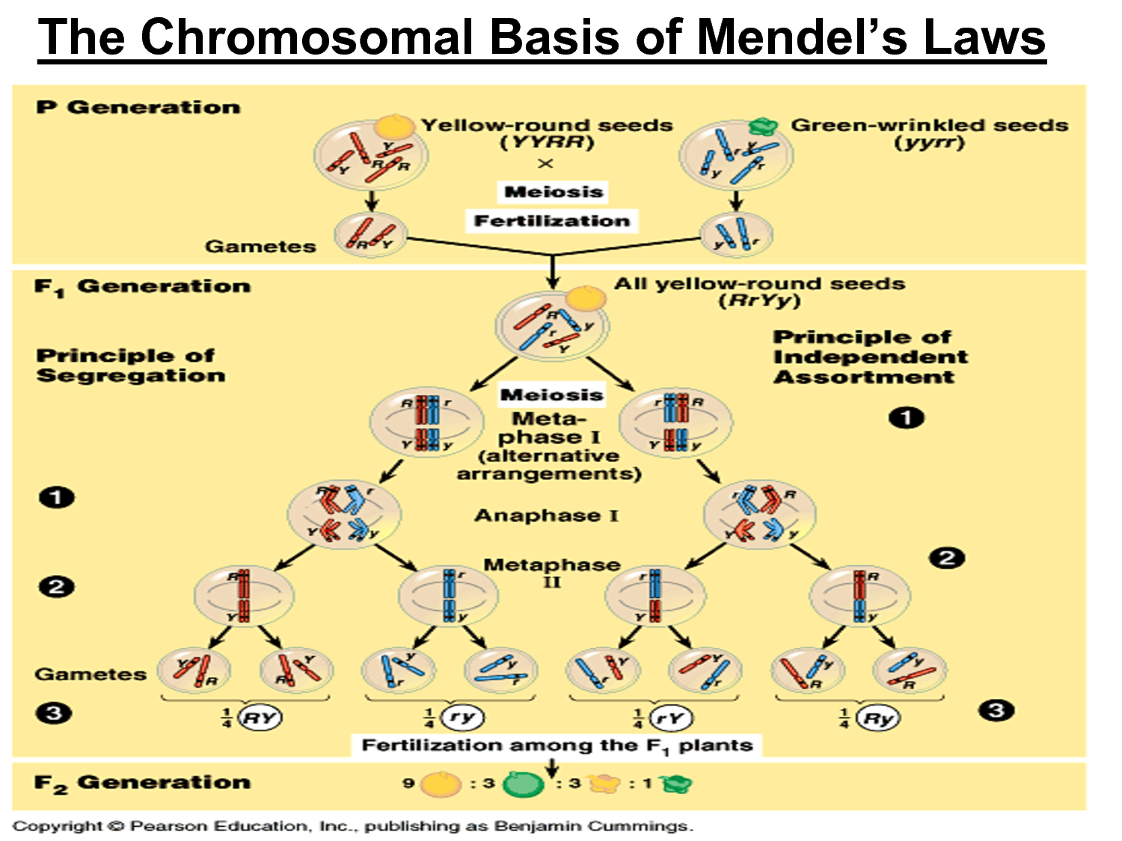

**But,**

**Inheritance patterns are often *more complex* than predicted by simple Mendelian genetics**

(basic principles of segregation and independent assortment still apply)

**Inheritance of characters by a single gene may deviate when…**

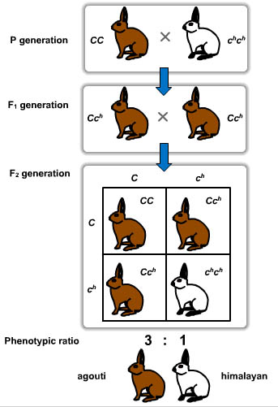

Complete Dominance

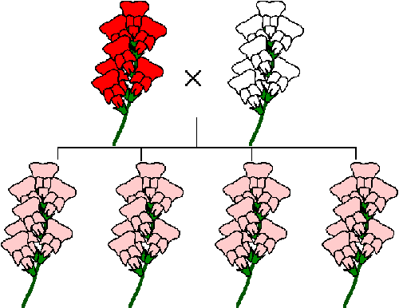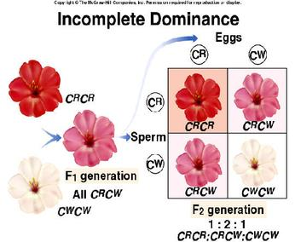Incomplete Dominance (think PINKomplete)

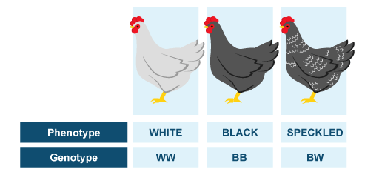 Codominance

Co-dominance

Multiple Alleles

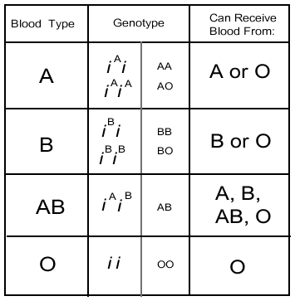

Sex-Linked Gene

X-linked recessive disorders are much more common in males than in females

X-linked human disorders examples:

X Inactivation in Female Mammals

Pleiotropy

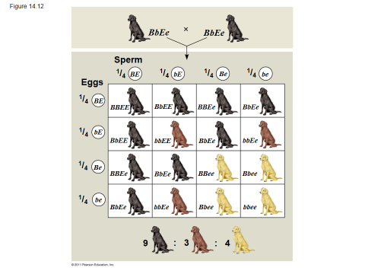

Epistasis

Polygenic Inheritance

Linked Genes

Genetic Recombination:

* 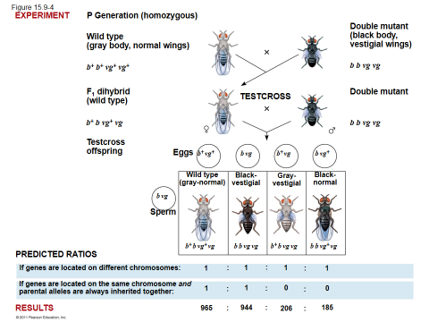**IF FREQUENCY < 50%,**

**THE GENES ARE LINKED!**

* 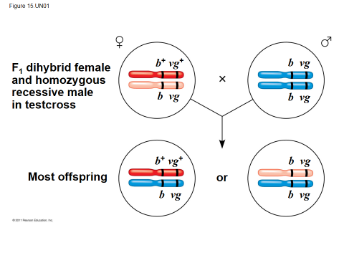Mechanism behind Recombination:  
   ________________________



**🡪Using the following crossover frequencies, construct a gene map for the following genes – A,B,C,D.**