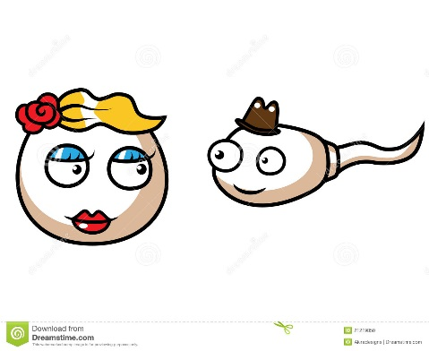
Meiosis
and Heredity

Living organisms are distinguished by their ability to reproduce their own kind

Vocab Review:
Genetics - study of heredity and variation
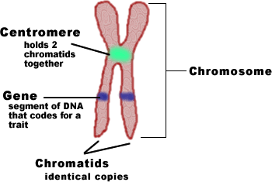
Heredity - transmission of traits from one generation to the next
Variation is the differences

How does heredity happen?
Genes:

Children inherit _____________ not ________________

Inheritance of Genes
Genes are passed on via _______________________ (sex cells – egg/sperm)

Most DNA is packaged into ______________________________

Asexual VS. Sexual Reproduction
Asexual -
Clone -
Sexual -

What About Us?
Humans have _________ pairs of chromosomes in a somatic cell (any cell other than a gamete)
Somatic cells are _________ or _________________ because
The 2 chromosomes in each pair are called ___________________________. They are:
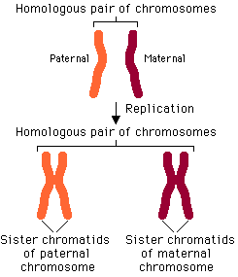
-
-
-
For Humans, the diploid (2N) number is ___________.
Somatic cell = ______________
Gamete =
Sex Chromosomes: ________ and _________
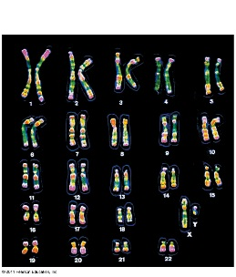
Human females: ________ Human males: __________
Autosomes:

Technique: Karyotype

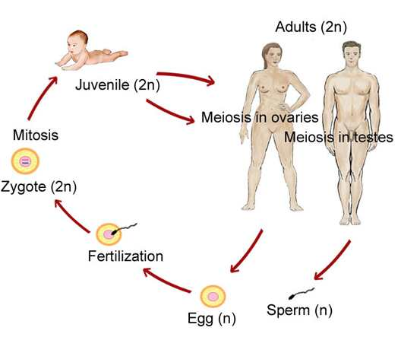
Fertilization and meiosis alternate in sexual life cycles

Or, in terms of chromosome sets…

There are 3 main types of Sexual Reproduction

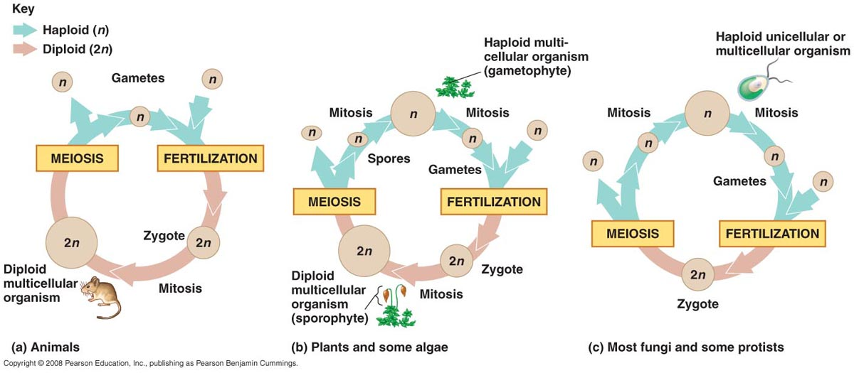

Animals…

Some plants and algae do things differently, and we call it ____________________________________________

You don’t need to concern yourself with the details of the other types of sexual reproduction. Just be aware they exist and there is more than way to have a diploid and haploid state during the reproduction cycle.

A NOTE ON HAP AND DIP: (1N and 2N)

In all three life cycles, the halving and doubling of chromosomes contributes to…
___________________________________________
Meiosis…

The Order of Events

In Brief,

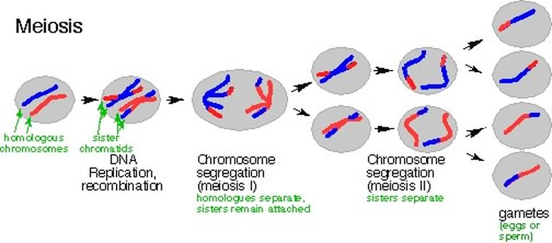

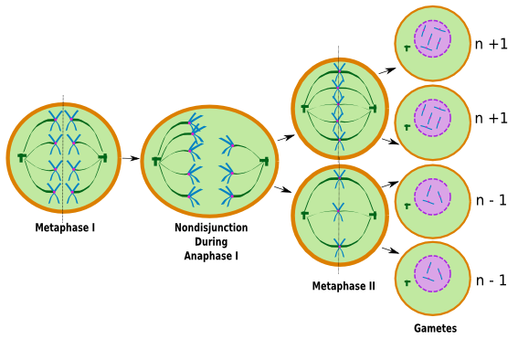
And at the END of Meiosis…

Non-disjunction in meiosis
Comparison of Meiosis and Mitosis

Mitosis Meiosis

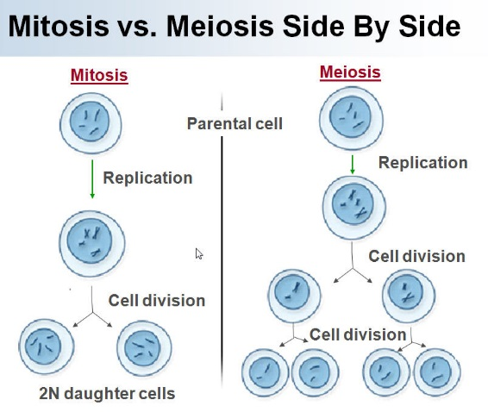

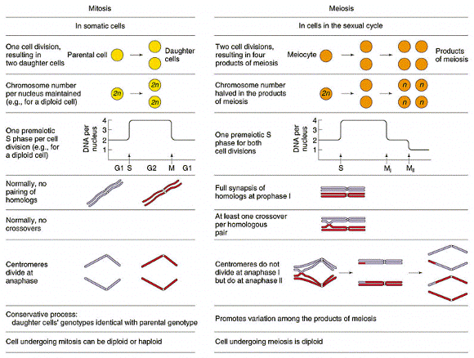

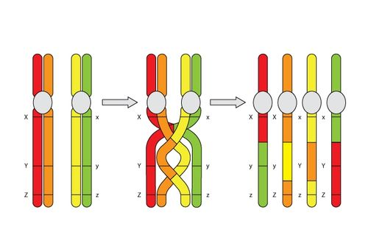
Genetic Variation – Origins in Offspring

Three mechanisms contribute to genetic variation:
1.
2.
3.

1. Crossing Over

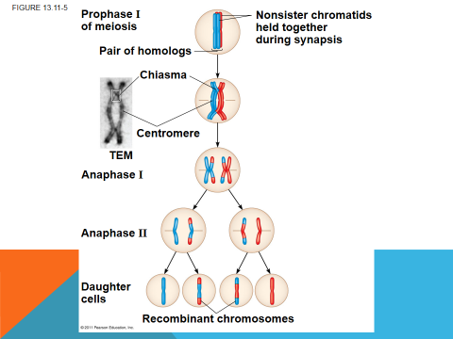

Creates _____________________ chromosomes

2. Independent Assortment of Chromosomes

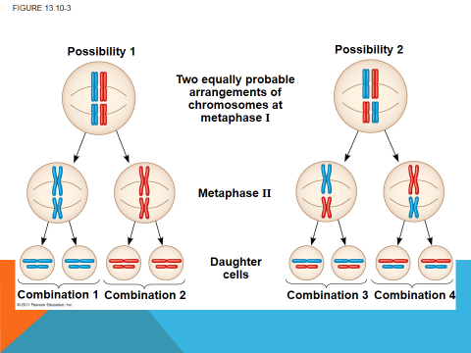

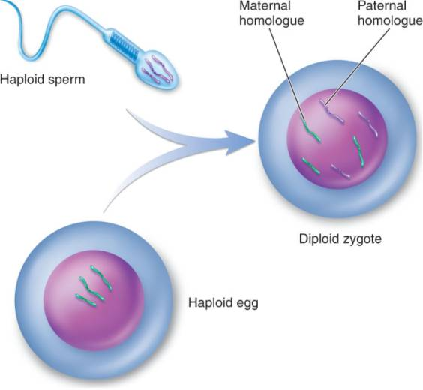
3. Random Fertilization

That Good Ole’ Evolution Connection…

Genetic variation produced in sexual life cycles contributes to evolution

Therefore….
Sexual reproduction contributes to the genetic variation in a population, which originates from mutations
