Immunology

Innate vs. Adaptive Immunity
Innate Immunity | Adaptive Immunity
Pathogen recognized by receptors encoded in the germline | Pathogen recognized by receptors generated randomly
Receptors have broad specificity, i.e., recognize many related molecular structures called PAMPs (pathogen-associated molecular patterns) | Receptors have very narrow specificity; i.e., recognize a particular epitope
PAMPs are essential polysaccharides and polynucleotides that differ little from one pathogen to another but are not found in the host. | Most epitopes are derived from polypeptides (proteins) and reflect the individuality of the pathogen.
Receptors are PRRs (pattern recognition receptors) | In jawed vertebrates, the receptors are B-cell (BCR) and T-cell (TCR) receptors for antigen
Immediate response | Slow (3–5 days) response (because of the need for clones of responding cells to develop)
Little or no memory of prior exposure | Memory of prior exposure
Occurs in all metazoans | Occurs in vertebrates only

Cell-mediated Immunity
Cell-mediated immune responses also display memory and an equivalent to the secondary response.

Immunological Memory and Vaccines
Immunological memory provides the basis for the use of vaccines. These are preparations of infectious or toxic agents that have been altered so as not to cause disease. The alteration is not, however, so drastic as to destroy all the epitopes. The antibodies (and/or T cells) produced in response to the vaccine will also protect against the unaltered disease-producing agent.

Clonal Selection
The ability of the immune system to respond to an antigen exists before it ever encounters that antigen.

The immune system relies on the prior formation of an incredibly diverse population of:
- B cells (B lymphocytes) surfaces covered with thousands of identical copies of a receptor for antigen (the B-cell receptor for antigen = BCR)

- T cells (T lymphocytes) surfaces covered with thousands of identical copies of a T-cell receptor for antigen (TCR)

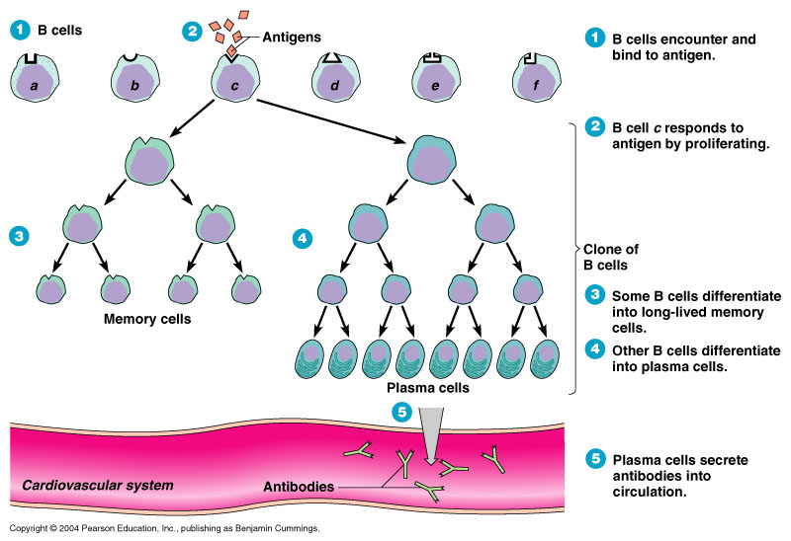
Each receptor is created even though the epitope it recognizes may never have been present in the body. If an antigen with that epitope should enter the body, those few lymphocytes able to bind to it will do so. If they also receive a second co-stimulatory signal, they may leave G₀ of the cell cycle and begin repeated rounds of mitosis (the cells are now called lymphoblasts). In this way, clones of antigen-specific lymphocytes (B and T) develop providing the basis of the immune response.

Clonal Selection leads to…

- a pool of antibody-secreting plasma cells. Plasma cells are B-cells that have tooled up for massive synthesis and secretion of an antibody. The antibody is the secreted version of the BCR.

- a pool of "memory" cells. These are B lymphocytes with receptors of the same specificity as those on the original activated B cell.

Immunological Memory

After recovering from an infection, the concentration of antibodies against the infectious agent gradually declines over the ensuing weeks, months, or even years. A time may come when antibodies against that agent can no longer be detected. Nevertheless, the individual often is still protected against a second case of the disease; that is, the person is still immune. In fact, a second exposure to the agent usually calls forth a more rapid and larger response to the antigen. This is called the secondary response.
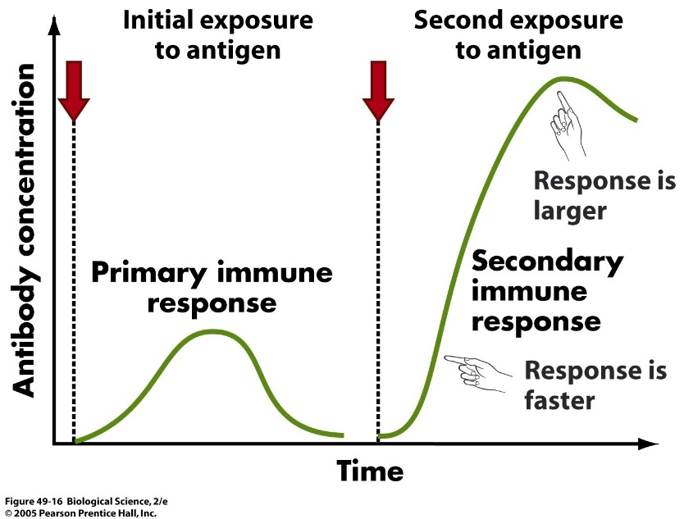

The secondary response reflects a larger number of antigen-specific cells — called memory cells — than existed before the primary response. During the initial expansion of clones, some of the progeny cells neither went on dividing nor developed into plasma cells. Instead, they reverted to small lymphocytes bearing the same BCR on their surface that their ancestors had. This lays the foundation for a more rapid and massive response the next time the antigen enters the body.

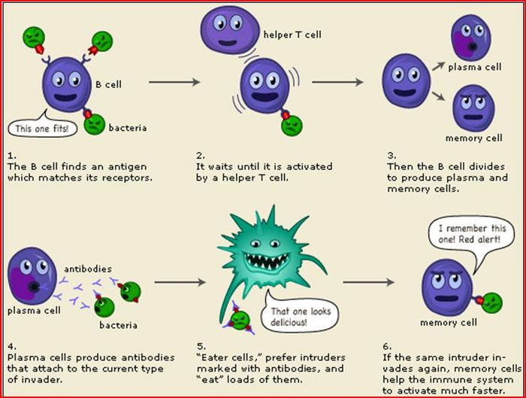
Immunological Memory and Vaccines
Immunological memory provides the basis for the use of vaccines. These are preparations of infectious or toxic agents that have been altered so as not to cause disease. The alteration is not, however, so drastic as to destroy all the epitopes. The antibodies (and/or T cells) produced in response to the vaccine will also protect against the unaltered disease-producing agent.
1. Using this packet and your book, complete the following chart about the immune system.
Type of Cell/Molecule | Description of Function
Lymphocytes (general, what’s included)
Helper T Cells
Cytotoxic T Cells
B Cells
Antigen Presenting Cells
Antigens
MHC (major histocompatibility complex)
Natural Killer Cells

2. Why are B cells called B cells and T cells called T cells?

3. What is phagocytosis? How is it related to immune system function?

4. What is a macrophage?

5. How does the immune system “remember” pathogens with which it’s come in contact with before?

6. What is contained in a vaccine and how does it give a person protection from pathogens?

Questions about the Immune System:
A pathogenic bacterium has been engulfed by a phagocytic cell as part of the nonspecific (innate) immune response. Which of the following illustrations best represents the response?
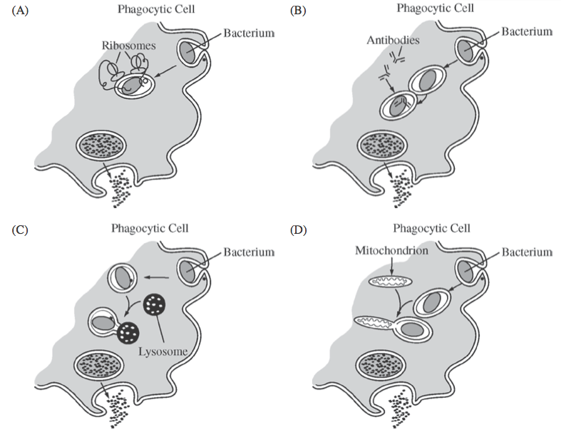
- Why do tissues swell during inflammation?
  - Tissues swell during inflammation because of the volume of bacteria present in the wound.
  - Tissues swell during inflammation because of the number of blood cells attacking the bacteria.
  - Tissues swell during inflammation because the increased permeability of capillaries causes fluids to accumulate in the area.
  - Tissues swell during inflammation only because of the accumulation of pus.

- How are B cells activated?
  - A B cell is activated when it encounters an antigen that matches its B cell receptors and receives cytokine signals from helper T cells.
  - B cells are activated when they encounter their twin T cell component.
  - Be cells are activated when red blood cells release cytokines.
  - B cell are activated when their matching antibodies attach to their surfaces and macrophages release cytokines.

- The following events occur when a mammalian immune system first encounters a pathogen. Place them in correct sequence, and then choose the answer that indicates that sequence.

I. Pathogen is destroyed.
II. Lymphocytes secrete antibodies.
III. Antigenic determinants from pathogen bind to antigen receptors on lymphocytes.
IV. Lymphocytes specific to antigenic determinants from pathogen become numerous
V. Only memory cells remain.
- IIIIIIIVV B. IIIIIIVIV C. IIIIVIIIV
- IIIIVIIIV

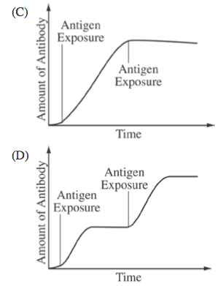
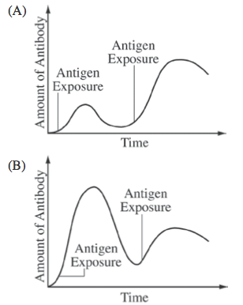
- An individual’s humoral response to a particular antigen differs depending on whether or not the individual has been previously exposed to that antigen. Which of the following graphs properly represents the humoral immune response when an individual is exposed to the same antigen more than once?

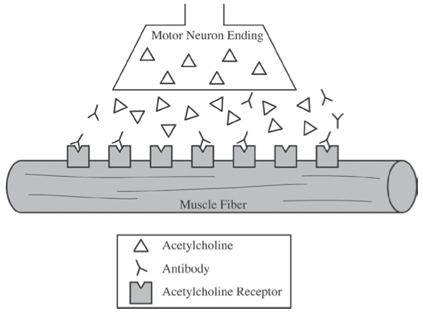
- The illustration below depicts a neuromuscular junction of a patient with an autoimmune disorder. Acetylcholine is a stimulatory neurotransmitter. Which of the following would be the most likely result of the continued presence of the antibody?

- An increase in action potentials in the motor neuron and constant nerve pain.
- A decrease in action potentials in the muscle, causing muscle weakness and fatigue.
- A decrease in the opening of sodium-gated channels in the muscle, causing less sodium to be released from the muscle.
- An increase in the opening of sodium-gated channels in the motor neuron because of the accumulation of acetylcholine in the junction.

