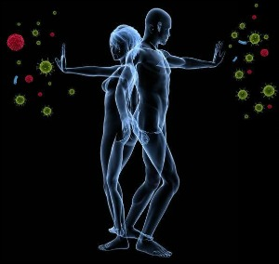
Immune System

Terms you should be able to define by the end of this:
- Pathogen - Antigen
- Antibody - Vaccine
- Allergen

Questions you should be able to answer by the end of this:
- What is the difference between innate vs. adaptive immunity?
- Contrast the functions of B cells and T cells.
- How are antigens recognized by immune system cells?
- What are memory cells?
- How does HIV affect the immune system?

Types of Immunity
Innate Immunity | Adaptive Immunity
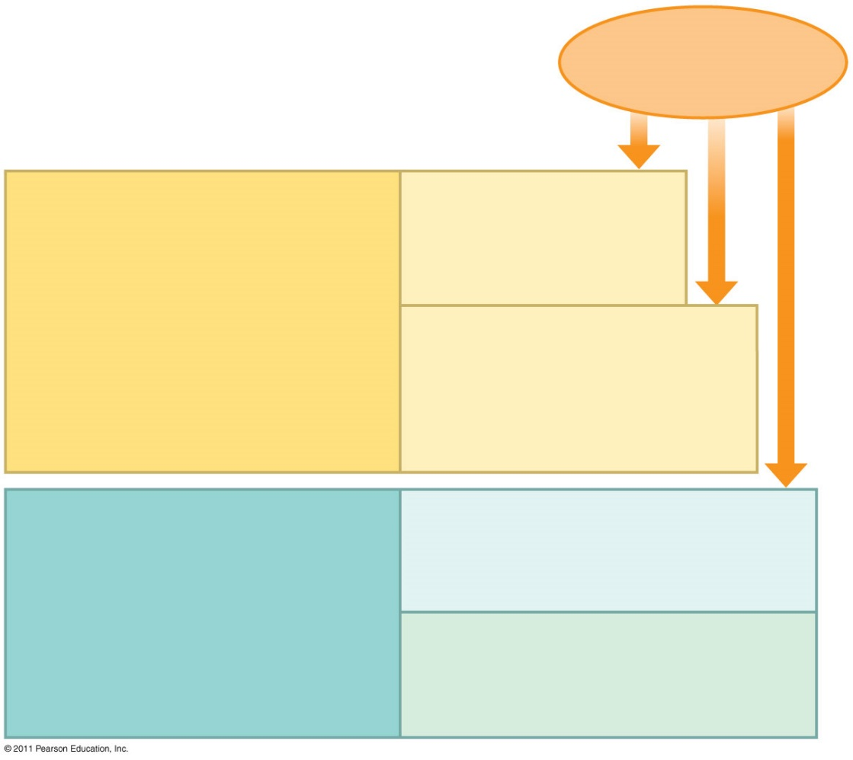
Plant Defenses
- Nonspecific responses
- Receptors recognize pathogen molecules trigger defense responses
  - Thicken cell wall, produce antimicrobial compounds, cell death
- Localize effects
INNATE IMMUNITY Barrier Defenses:
( all ___________)

Internal Defenses:
Phagocytic cells
Natural killer cells
Antimicrobial proteins
Inflammatory response

ADAPTIVE IMMUNITY Humoral Response:
( ________________ only)

Cell Mediated Response:

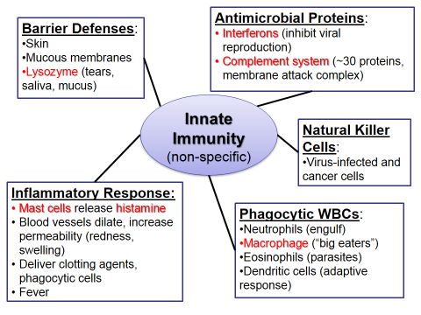

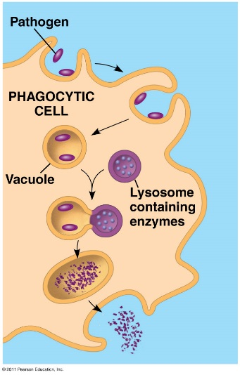
Phagocytosis: Inflammatory Response:
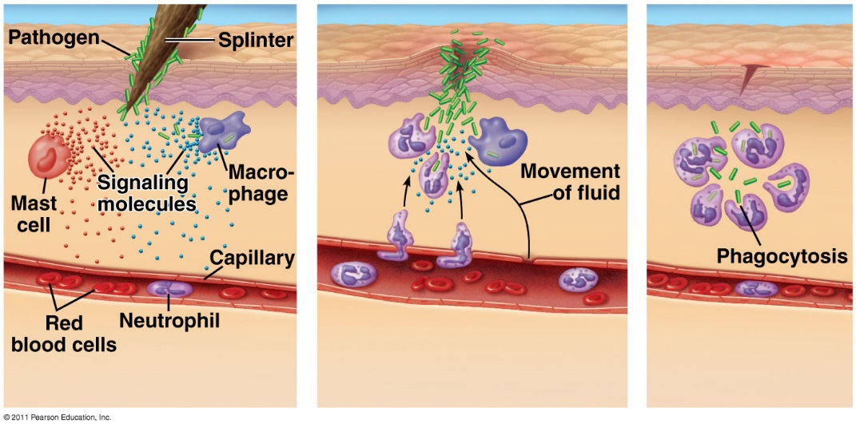

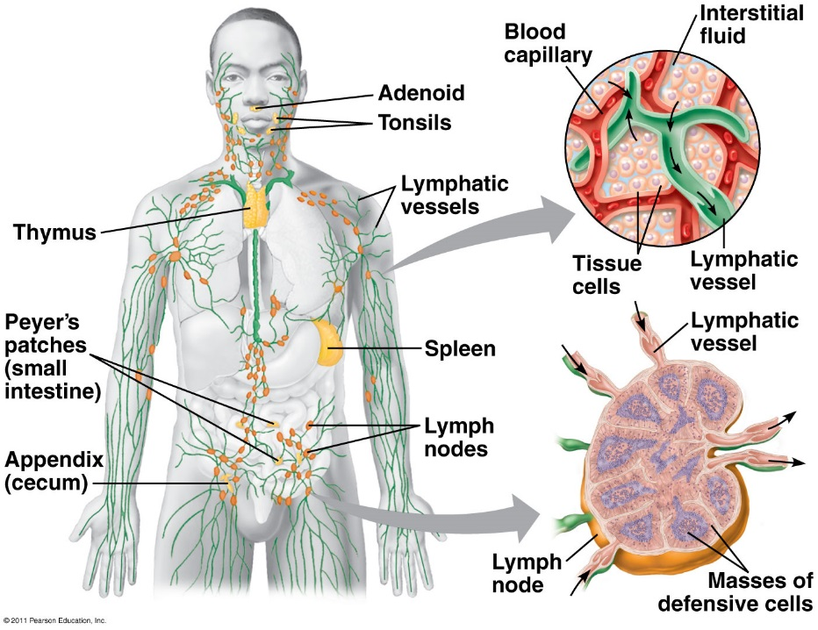

Lymphatic System:

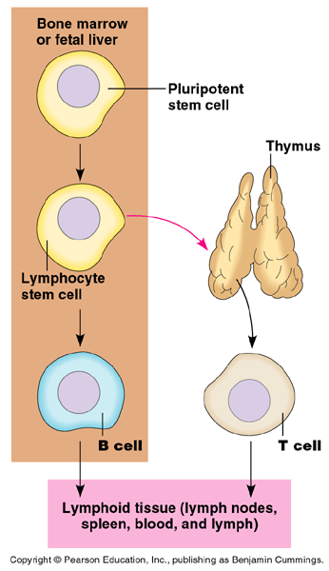
Adaptive Response
Lymphocytes (_____)

- T Cells

- B Cells
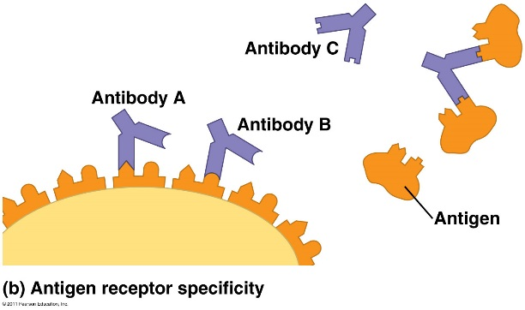

- Antigen

- Antibody

Major Histocompatibility Complex (_____)
- ______________ displayed on _____________
- Responsible for tissue/organ rejection (“self” vs. “non-self”)
- ____________________________________________________

- Class I: all body cells (except RBCs)
- Class II: displayed by immune cells; “non-self”

Proliferation of B and T cells

- In the body there are few lymphocytes with antigen receptors for any particular epitope
- In the lymph nodes, an antigen is exposed to a steady stream of lymphocytes until a match is made
- This binding of a mature lymphocyte to an antigen initiates events that activate the lymphocyte

Once activated…
- a B or T cell undergoes multiple _______________
- This proliferation of lymphocytes is called ____________________
- Two types of clones are produced: short-lived activated ________________
that act immediately against the antigen and _________________________ that can give rise to effector cells if the same antigen is encountered again

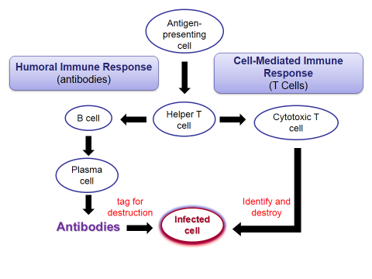
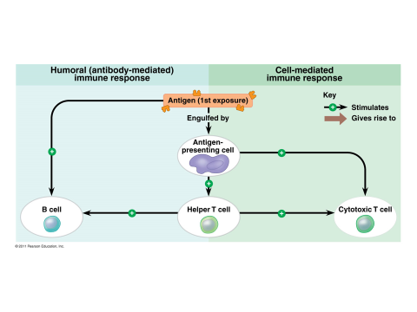

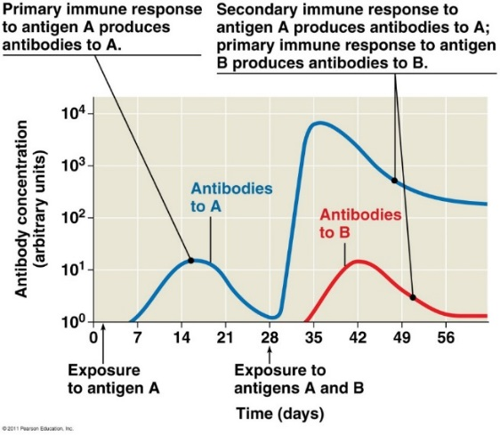

Immunological Memory
- Primary immune response:

- Memory cells:
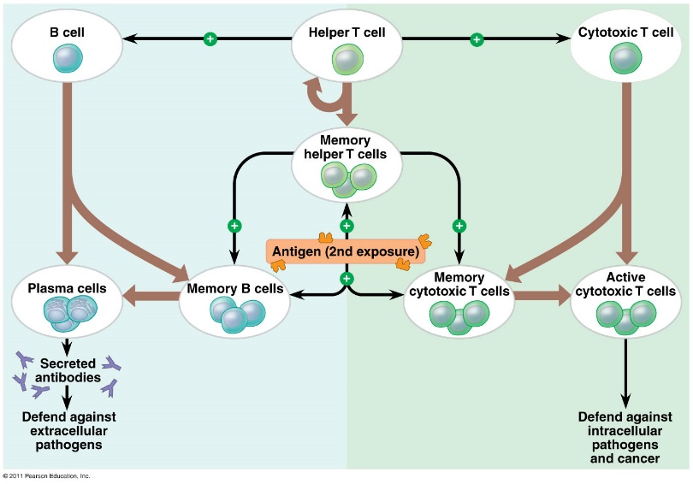
  - Secondary immune response:

Adaptive immunity defends against infection of body fluids and body cells

- Acquired immunity has 2 branches:

Humoral Immune Response:

Cell Mediated Immune Response:

The Different Types of Cells Involved in Immune Response
Helper T-Cells: A response to nearly all antigens

- Antigen-presenting cells have class I and class II MHC molecules on their surfacesClass II MHC molecules are the basis upon which antigen-presenting cells are recognized
- Antigen receptors on the surface of helper T cells bind to the antigen and the class II MHC molecule; then signals are exchanged between the two cells
- The helper T cell is activated, proliferates, and forms a clone of helper T cells, which then activate the appropriate B cells
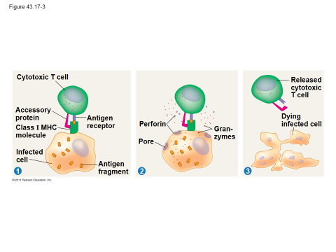
Cytotoxic T Cells: A Response to Infected Cells

B Cells and Antibodies: A Response to Extracellular Pathogens
- The humoral response is characterized by secretion of __________________
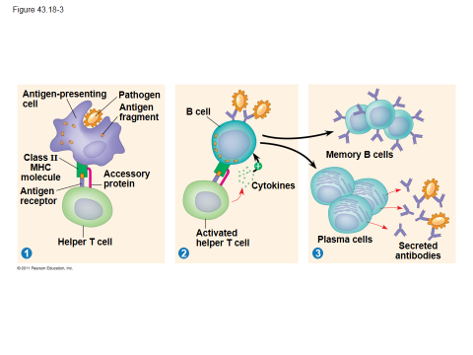
- Activation of the humoral immune response involves ___________________
as well as _____________ on the surface of ________________
- In response to cytokines from helper T cells and an antigen, a B cell proliferates
and differentiates into ______________ and antibody secreting effector cells
called ______________

Antibody Function:
**

- In Neutralization…

- In Opsonization…

- Ultimately a membrane attack complex forms a pore in the membrane of the foreign cell, leading to its lysis

B cells can express five different forms (or classes) of immunoglobulin (Ig) with similar antigen-binding specificity but different heavy chain C regions:

Immunizations/vaccines:
Passive immunity:
Allergies:
Autoimmune Diseases:
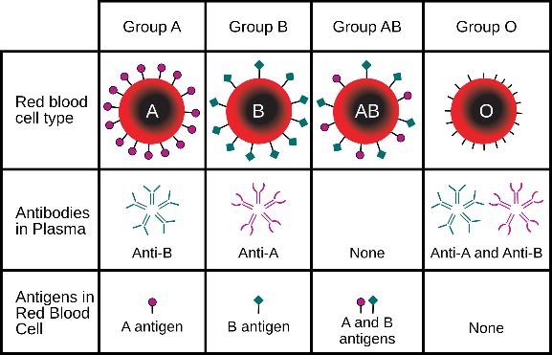
HIV:

Immune Rejection:

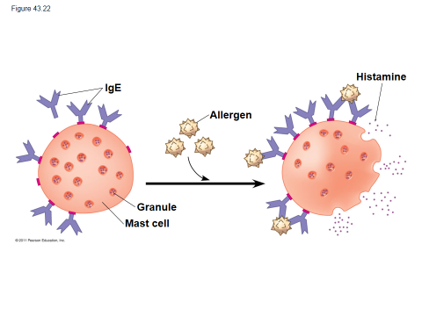
Tissue and Organ Transplants:

Allergies:

Autoimmune Diseases:

