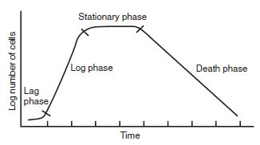 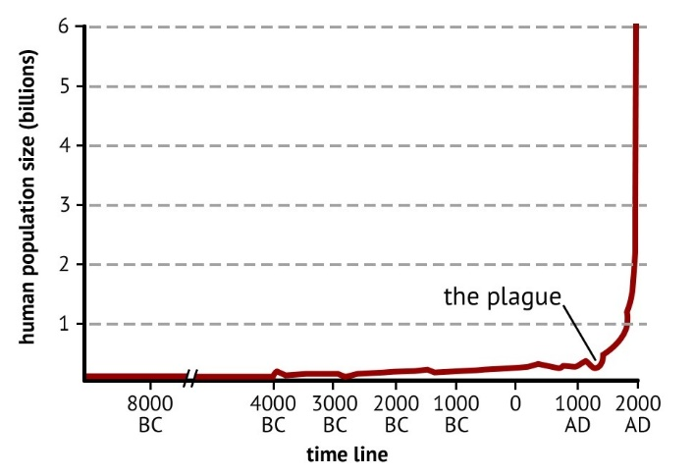

Look at the following graphs and fill in the missing words in the boxes. (word bank: Unrestricted Deer Population, Bacteria Growth, Exponential Growth Graph, Predator-Prey Populations, carrying capacity, human population, timeline, # of deer, deer pop., carrying capacity, predator, prey, plague, reduced carrying capacity

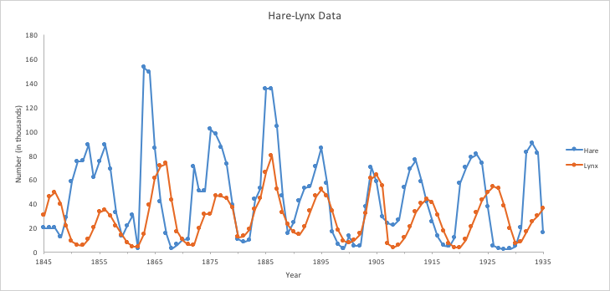 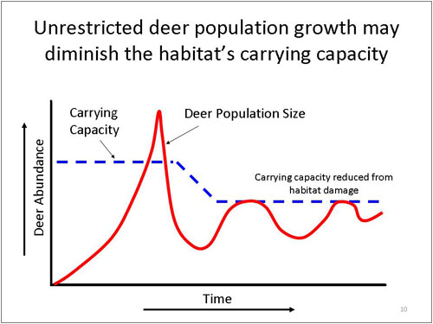

(Answers on the next page)

 

Exponential Growth Graph

Bacterial Growth Graph

 

Prey

predator

Predator-Prey Population Graph

`