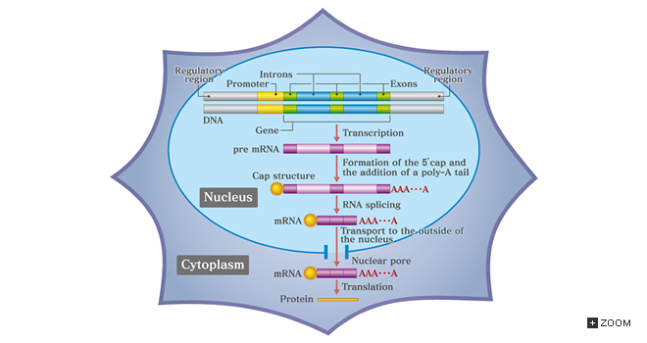
Gene Regulation
Eukaryotes

- How are genes turned on & off in eukaryotes?
- How do cells with the same genes differentiate to
perform completely different, specialized functions?

Why did Gene Regulation Evolve?
Prokaryotes
  - single-celled
  - evolved to grow & divide rapidly
  - must respond quickly to changes in external environment
  - exploit transient resources – lac and trp operons
Gene regulation
  - turn genes on & off rapidly -- flexibility & reversibility
  - adjust levels of enzymes for synthesis & digestion
Eukaryotes
  - multicellular
  - evolved to maintain constant internal conditions while facing changing external conditions homeostasis
  - regulate body as a whole
1. __________________ & _____________________ (long term processes)
2. ____________________________
turn on & off large number of genes
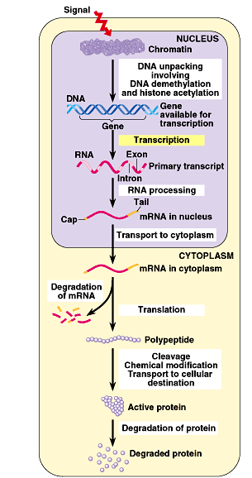
______ of genes are turned on in a typical cell

Points of control –
The control of gene expression can occur at any step in the path from gene to functional protein
1. ________________________
2. ________________________
3. ________________________
4. ________________________
5. ________________________
6. ________________________
7. ________________________
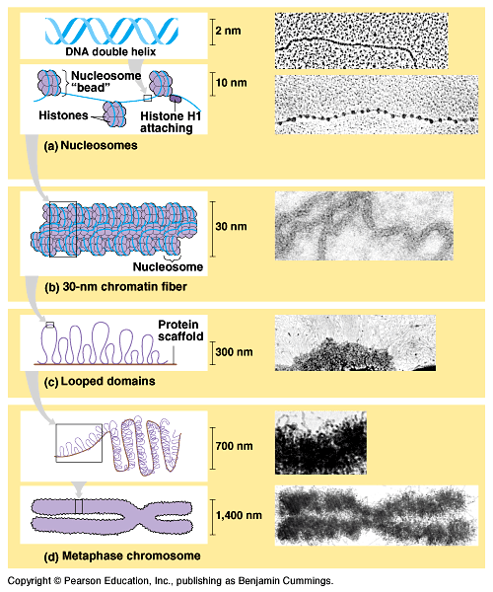
1.DNA Packing
How do you fit all that DNA into the nucleus? It’s packaged!
DNA coiling & folding
double helix Nucleosomeschromatin fiber looped domainschromosome
- Nucleosome: “Beads on a string”
  - .
  - .
    - 8 protein molecules
    - positively charged amino acids
    - bind tightly to negatively charged DNA
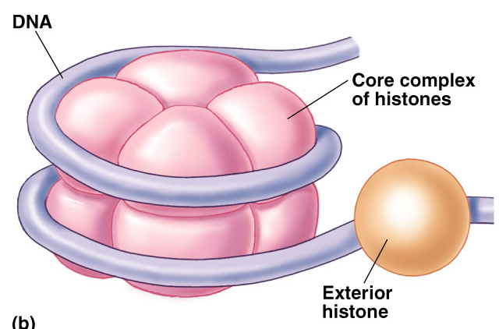
Epigenetics Inheritance
- Degree of packing of DNA regulates ______________________
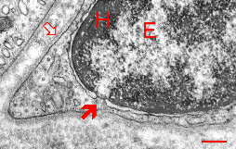
  - .

Heterochromatin (darker DNA = tightly packed)
Euchromatin (lighter DNA = loosely packed

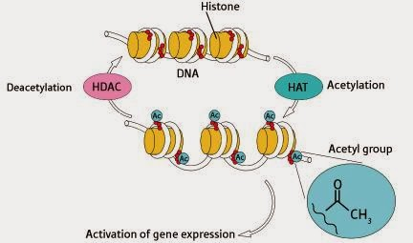
Histone Acetylation
    - Acetylation of histones __________________

DNA Methylation
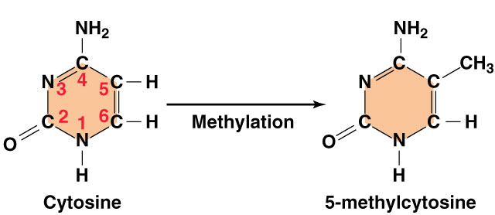

Genomic Imprinting

- 1 allele is silenced by DNA methylation
- Only 1 copy of certain genes is needed for normal development
- If 0 or 2 genes is active, then major developmental problems can occur
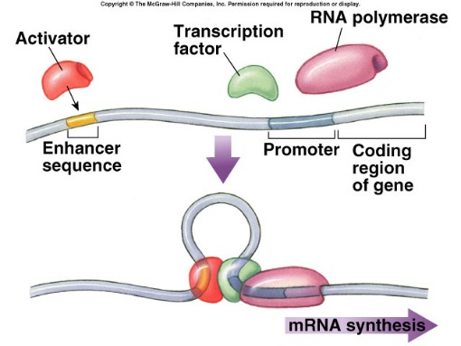
2. Transcription initiation
Control regions on DNA
  - ____________________

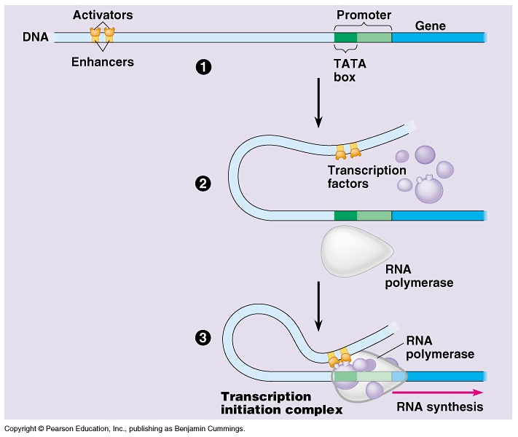

  - _____________________

Model for Enhancer Action
Enhancer DNA sequences

Activator proteins

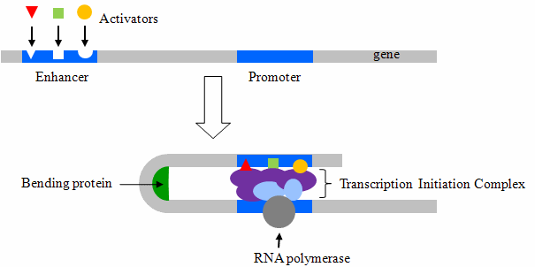
Silencer proteins

Classes of Transcription Factors
General

Specific

Transcription Initiation Complex
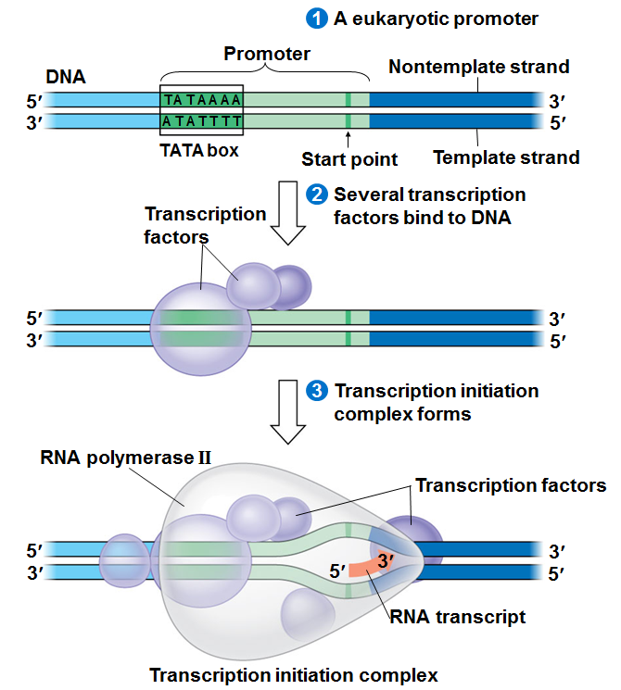

Signal Transduction Pathways
A signal molecule can…

Coordinated Control of Genes
Related genes are clustered together

Related genes have the same combination of control elements

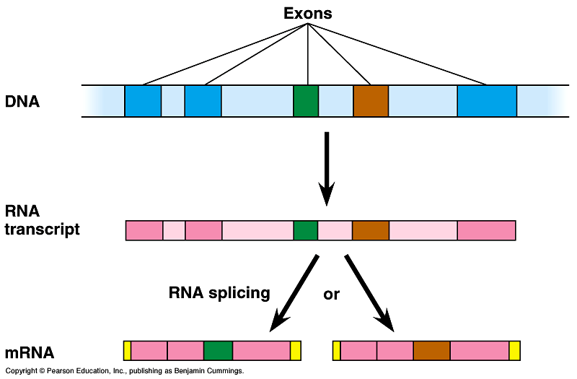
3. Post-transcriptional control

4. Regulation of mRNA degradation

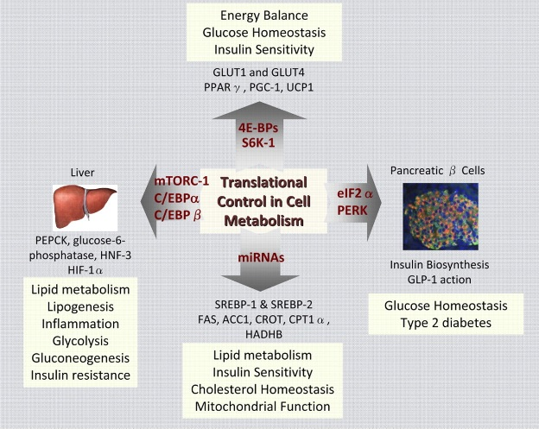
5. Control of translation
Block initiation of ________________________ stage

- prevent attachment of ribosomal subunits & initiator tRNA
- block translation of mRNA to protein

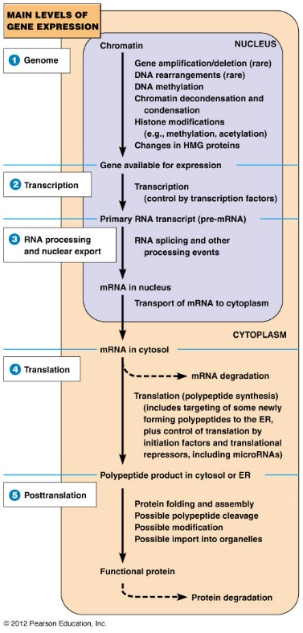
6-7. Protein processing & degradation
  - Protein processing

  - Protein degradation
    - _________________ tagging
    - _______________________ degradation

Ubiquitin = “_________________________”
  - mark unwanted proteins with a label
  - 76 amino acid polypeptide, ubiquitin
  - labeled proteins are broken down rapidly in "waste disposers“
(proteasomes)

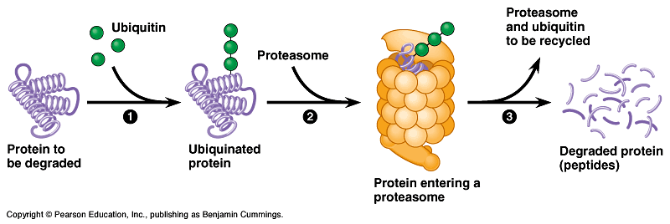
Proteasome = ___________________________________________

Gene Regulation and Developmental Control
- How does one cell (*zygote) become all of the different types of cells (~200!) in the body?
- If all cells have the same DNA and genetic information in them, what makes them different cells?
Answer: their genetic expression
- How do they “know” what genes to have turned on and turned off to be that type of cell?

Differentiation

Morphogenesis

Developmental Signals can come from:

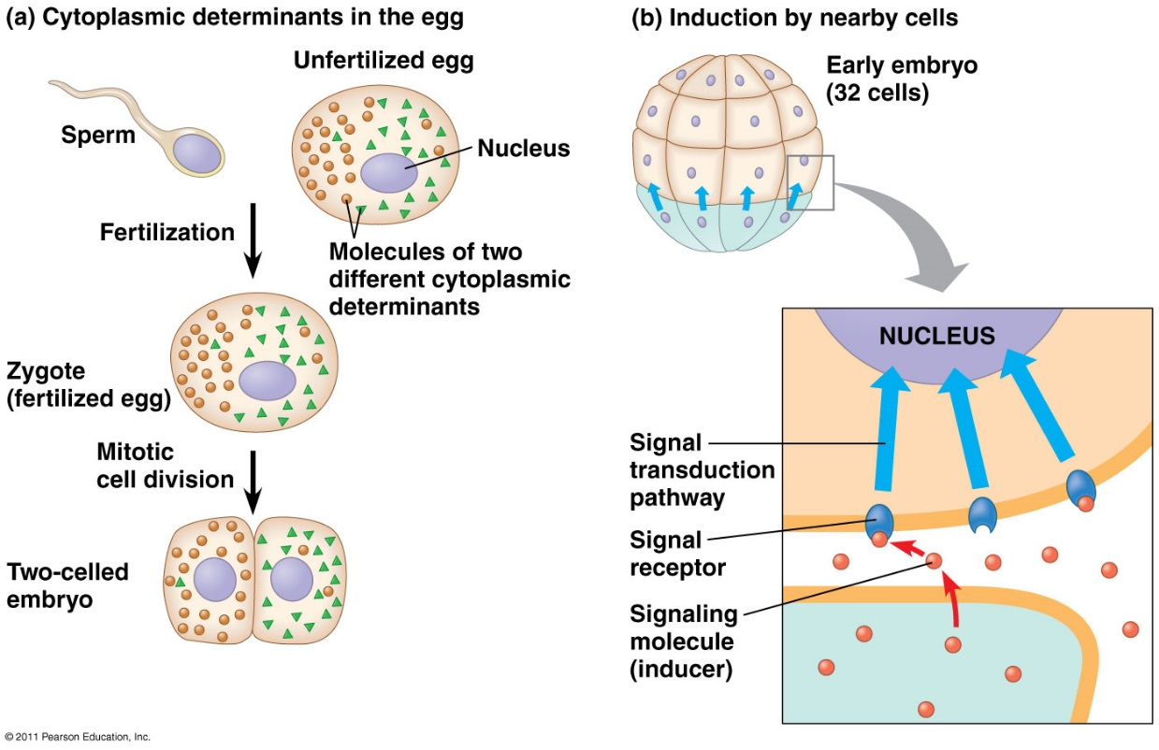

- The unfertilized egg has molecules in its cytoplasm, encoded by the mother’s genes, that influence development. These are unevenly distributed in the egg, so when they egg starts to divide after fertilization, the cell nuclei of the embryo are exposed to different sets and amounts of them, and as a result express different genes.
- Cells at the bottom of the early embryo are releasing chemicals that single nearby cells to change their gene expression. Location of cells plays a huge role!

Morphogens
- Chemical signals that form a concentration gradient as they spread away from their source. The fate of each cell depends on the concentration of these molecules they are exposed to.

