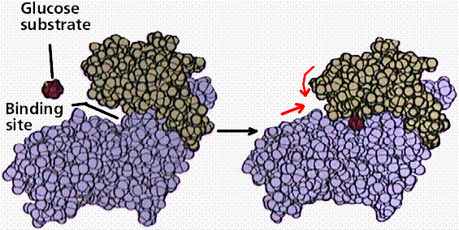
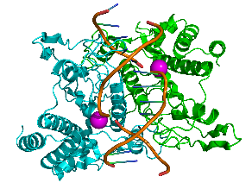
ENZYMES

What are enzymes?

The living cell is a miniature ______________________ where MILLIONS of ___________________________.

Metabolism:

Metabolic Pathway:

_____________________ pathways release energy.

_____________________ pathway consume energy.

Bioenergetics:
Laws of Thermodynamics (a review):
  - 1st law – Energy cannot be created or destroyed it only be transferred or transformed
  - 2nd law – Every energy transfer increases the entropy of the universe

Energy flows INTO and ecosystem as _____________________ and exists as ___________________.

- The free-energy change of a reaction tells us whether or not the reaction occurs spontaneously.

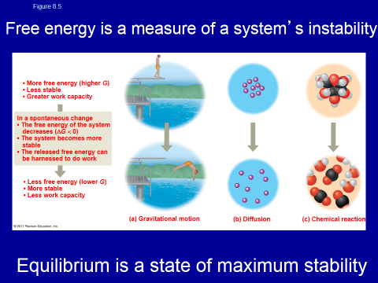
Free energy =

Endergonic Reactions and Exergonic Reactions:

Exergonic:

Endergonic:

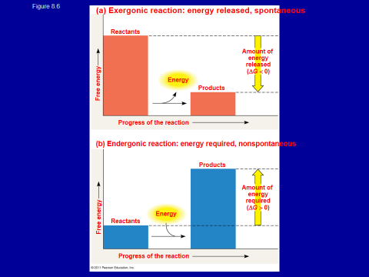
Energy Coupling Reactions

In the cell, the energy from the exergonic reaction of ATP hydrolysis can be used to drive an endergonic reaction. It’s driven by ___________________________.

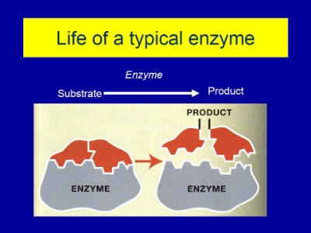
Why do we need enzymes?

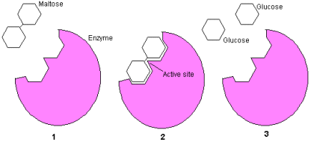
- What do enzymes do to the activation energy of a reaction? They ________________________________.

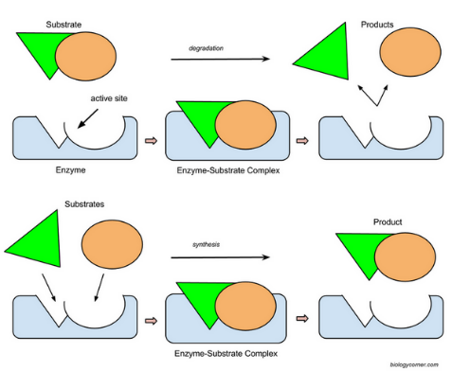
What are the parts/players in an enzymatic reaction?

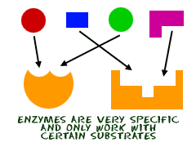

Enzymes are SPECIFIC

Induced Fit Model
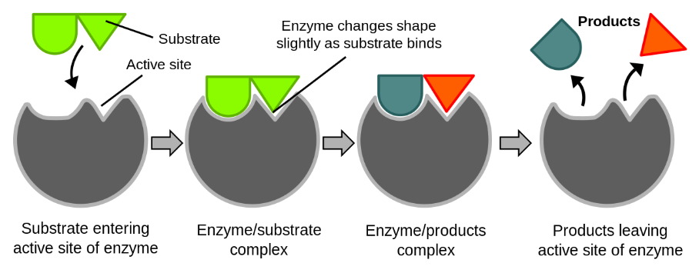

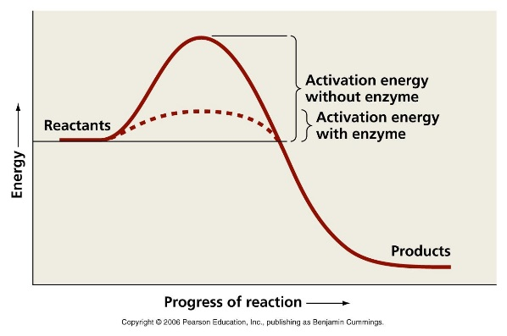
Activation Energy

DIFFERENT FACTORS CAN INFLUENCE AN ENZYMATIC REACTION

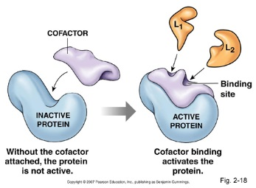
- Cofactors

examples: Vitamin C
Folic Acid
Vitamin D

ENZYME INHIBITORS

Two types: ____________________________________ and ____________________________________

Competitive Inhibitors Non-competitive Inhibitors
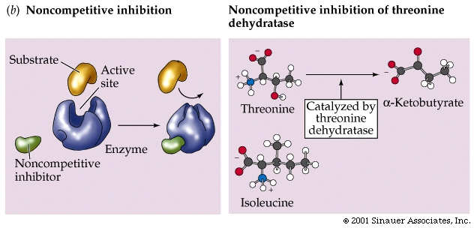
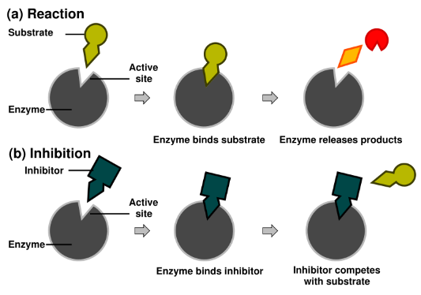

Allosteric Regulation – (Non-competitive inhibition)
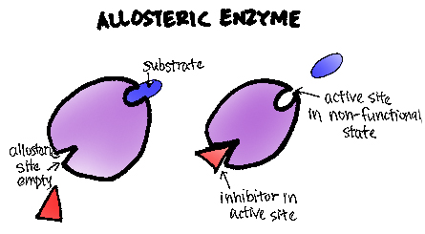

- FEEDBACK INHIBITION!!! (why is it important?)
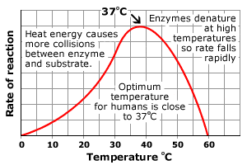

- Temperature

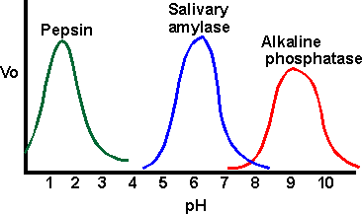

- pH

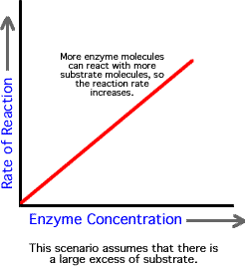
- Substrate/Enzyme Concentrations
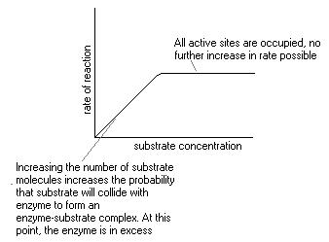

- Time

