Name: ________________________________ Date: __________
Chapter 6 Study Guide

Concept 6.2

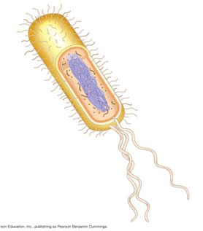
1. On the sketch of a prokaryotic cell, label each of
these features and give its function or description.
cell wall

plasma membrane

bacterial chromosome

nucleoid

cytoplasm

flagella

2. Why are cells so small? Explain the relationship of surface area to volume.

Concept 6.3 The eukaryotic cell’s genetic instructions are housed in the nucleus and carried out by the ribosomes

3. In the figure below, label the nuclear envelope, nuclear pores, and pore complex.

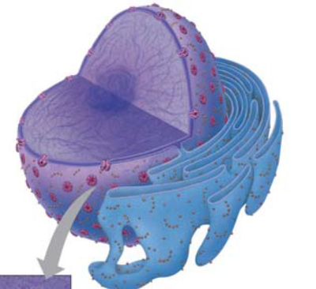
4. Describe the nuclear envelope. How many layers is it? What connects the layers?

5. What is the nuclear lamina? Nuclear matrix?

6. Found within the nucleus are the chromosomes. They are made of chromatin. What are the two components of chromatin?

7. When do the thin chromatin fibers condense to become distinct chromosomes?

8.When are the nucleoli visible? What are assembled here?

9.There are free ribosomes and bound ribsomes. Distinguish between them by giving their locations and products.
Product Location
Free ribosomes:

Bound ribosomes:

Concept 6.4 The endomembrane system regulates protein traffic and performs metabolic functions in the cell

10. List all the structures of the endomembrane system.

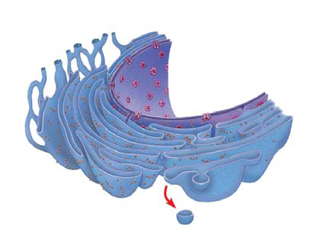
11. The endoplasmic reticulum (ER) makes up more than half the total membrane system in many eukaryotic cells. Use this sketch to explain and LABEL the lumen, transport vesicles, and the difference between smooth and rough ER.

12. List and describe three major functions of the smooth ER.

13. The rough ER is studded with ribosomes. As proteins are synthesized, they are threaded into the lumen of the rough ER. Some of these proteins have carbohydrates attached to them in the ER to form glycoproteins. What does the ER then do with these secretory proteins?

14. Besides packaging secretory proteins into transport vesicles, what is another major function of the rough ER?

15. The transport vesicles formed from the rough ER fuse with the Golgi apparatus.
Use this sketch to label the cisterna of the Golgi apparatus, and its cis and trans faces.
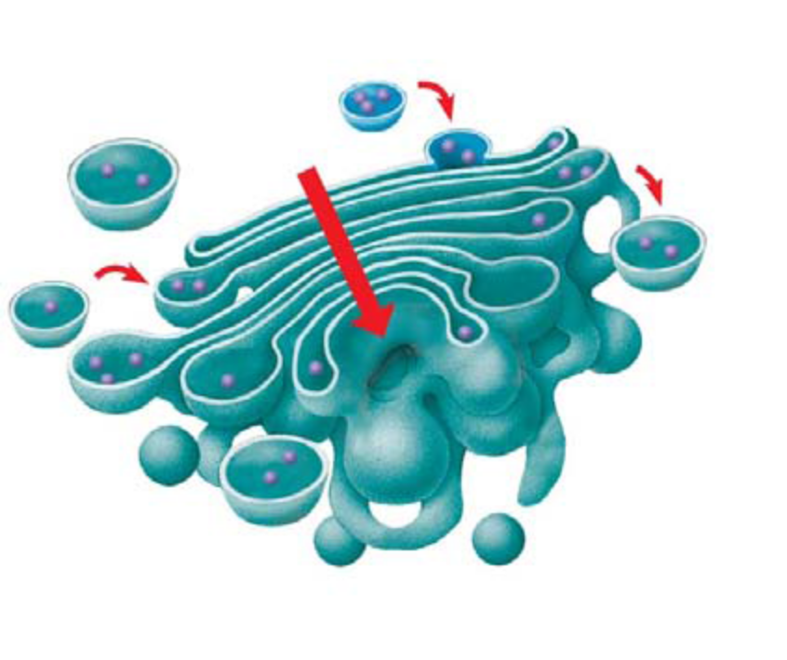
Describe what happens to a transport vesicle and its contents when it arrives at the Golgi.

16. What is a lysosome?

17. Describe phagocytosis. What structures are involved?

18. Describe autophagy. What structures are involved?

19. Explain the role of lysosomes in TaySachs disease.

20. What is a contractile vacuole? How does it differ from a central food vacuole?

21. Use this figure to explain how the elements of the endomembrane system function together to secrete a protein and to digest a cellular component. Label as you explain

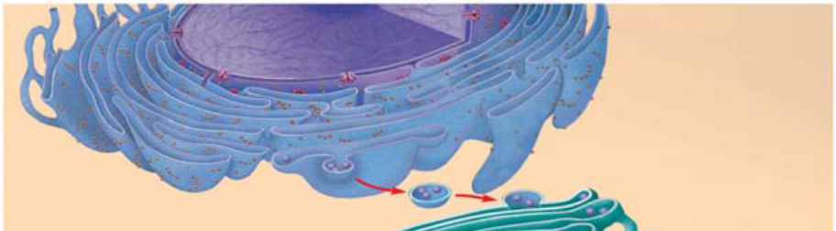

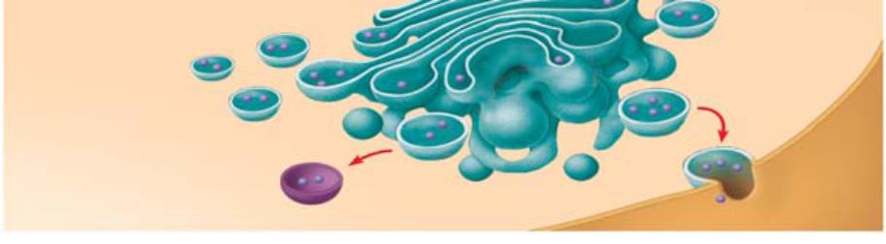

Concept 6.5 Mitochondria and chloroplasts change energy from one form to another

22. In the space below, draw a chloroplast and a mitochondrion. Label the important parts (grana, stroma, thylakoids, inner and outer membranes) and (inner and outer membranes, cristae, ribosomes, matrix). Also, list the function below the sketch.

Mitochondria Chloroplast

Function: Function:

23. Recall the relationship of structure to function. Why is the inner membrane of the mitochondria highly folded? What role do all the individual thylakoid membranes serve? (Same answer for both questions.)

24. Explain the important role played by peroxisomes

Name: _______________________________________ Date: __________
Chapter 6 – part 2

Concept 6.6 The cytoskeleton is a network of fibers that organizes structures and activities in the cell

1. What is the cytoskeleton?

2. What are the three roles of the cytoskeleton?

3. There are three main types of fibers that make up the cytoskeleton. Name them.

4. Microtubules are hollow rods made of a globular protein called tubulin. Each tubulin protein is a dimer made of two subunits. These are easily assembled and disassembled. What are four functions of microtubules?

5. Animal cells have a centrosome that contains a pair of centrioles. Plant cells do not have centrioles. What is another name for centrosomes?

6. What is believed to be the role of centrioles?

7. Describe the organization of microtubules in a centriole. Make a sketch here that shows this arrangement in cross section.

8. Cilia and flagella are also composed of microtubules. The arrangement of microtubules is said to be
“9 + 2.” Make a sketch of a cross section here.

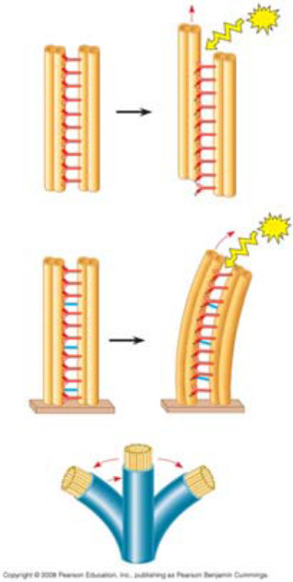

9. Compare and contrast cilia and flagella.

10. How do motor proteins called dyneins cause movement of cilia?
What is the role of ATP in this movement? (This figure might help you explain →)

11. Microfilaments are solid, and they are built from a double chain of actin. What are four functions of microfilaments?

12. What are the motor proteins that move the microfilaments?

13. Intermediate filaments are bigger than microfilaments but smaller than microtubules. They are more permanent fixtures of cells. Give two functions of intermediate filaments.

Concept 6.7 Extracellular components and connections between cells help coordinate cellular activities
14. What are three functions of the cell wall?

15. What is the composition of the cell wall?

16. What is the relatively thin and flexible wall secreted first by a plant cell?

17. What is the middle lamella? Where is it found? What material is it made of?

18. Explain the deposition of a secondary cell wall.

19. On the sketch, label the primary cell wall, secondary cell wall, middle lamella, cytosol,
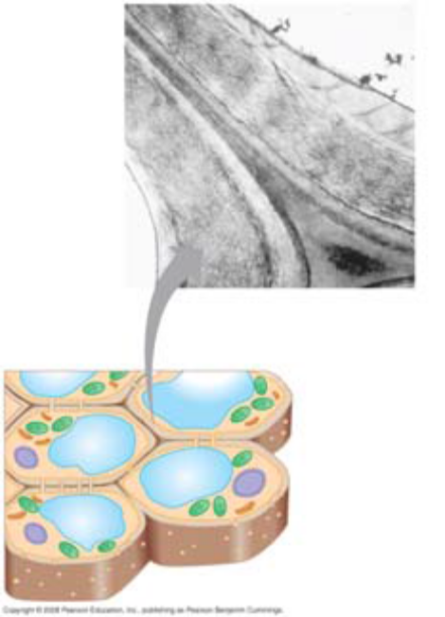
plasma membrane, central vacuole, and plasmodesmata

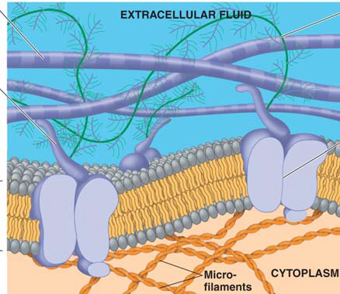
20. Animal cells do not have cell walls, but they do have an extracellular matrix (ECM). On this figure, label the elements indicated, and give the role of each.

21. What are the intercellular junctions between plant cells? What can pass through them?

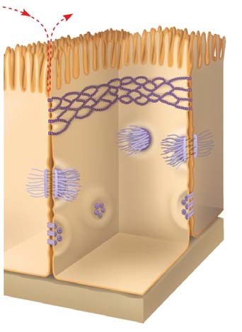
22. Animals cells do not have plasmodesmata. This figure shows the three types of intercellular junctions seen in animal cells. Label each type and summarize its role.

__________________________________

______________________________

__________________________________



