Cell Membrane Intro WS
Name: ______________________
- Substance can move across the membrane via simple diffusion, facilitated diffusion, or active transport.
Complete the chart:
 | Where does it occur in the membrane? | Does it require a transport protein? | Does it require an input of energy?
Simple diffusion
Facilitated diffusion
Active transport

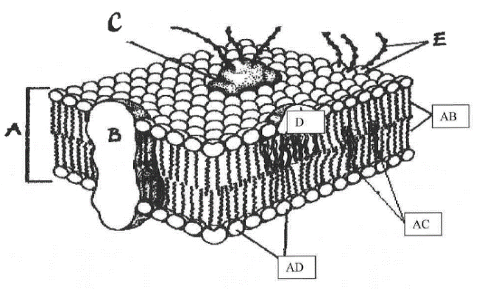
- Match the cell membrane function or structure with the correct letter from the diagram to the right.

___ Attracts water
___ Involved in cell-cell recognition
___ Repels water
___ Make up the bilayer
___ Help transport certain materials across membrane
___ Help maintain the structure

- Define these three terms:
- Hypertonic - __________________________________________________________
- Hypotonic - ___________________________________________________________
- Isotonic - _____________________________________________________________
- Use arrows to show the direction of water movement into or out of each cell. Label the cell in an isotonic environment, the hypotonic environment, and the hypertonic environment.
