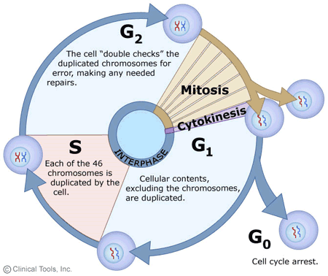**Cell Cycle and**

**Regulation of Division**

**Coordination of cell division**

* A multicellular organism needs to coordinate cell division across different tissues & organs
* Critical for _________________________, _____________________ and ____________________
* .

Frequency of Cell Division – varies by cell type

|  |  |
| --- | --- |
| ***cell type*** | ***how often do they divide?*** |
| embryo |  |
| skin cell |  |
| liver cell |  |
| mature nerve/muscle cells |  |

**Overview of Cell Cycle Control**

* **Two irreversible points in cell cycle**
  + .
  + ,
* **Checkpoints** 
  + .

**Checkpoint control system**

* **Checkpoints**
  + **.**
  + **.**

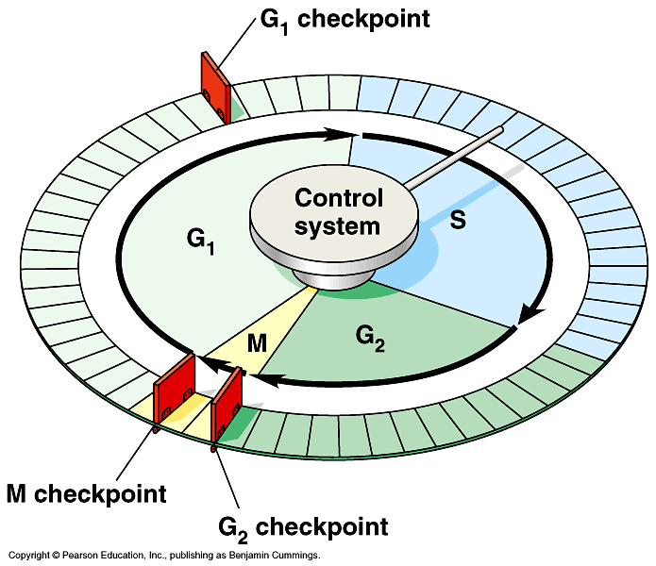**3 major checkpoints:**

* + **____________**
    - can DNA synthesis begin?
  + ______________
    - has DNA synthesis been completed correctly?
    - commitment to mitosis
  + _____________________
    - are all chromosomes attached to spindle?
    - can sister chromatids separate correctly?

**G1/S checkpoint**

* **.**
  + primary decision point
    - “restriction point”
  + if cell receives “GO” signal, it ___________________
    - internal signals: ___________________________________
    - external signals: ______________________
  + **cell cycleif cell does NOT receive signal -** 
    - **G0 =**
* **G0 Phase**
  + **non-dividing, differentiated state**
  + **.**
  + **.**
  + **.**
* “Go Ahead” Signals
  + External Signals
  + Intrinsic Signals

**Primary mechanism of control**

* + **.**
    - **kinase enzymes**
    - **.**

Cell Cycle Signals – Cell Cycle Controls

* + **.**
    - **.**
    - **.**
  + **.**
    - **cyclin-dependent kinases**
    - **.**
      * **activates or inactivates proteins**
  + 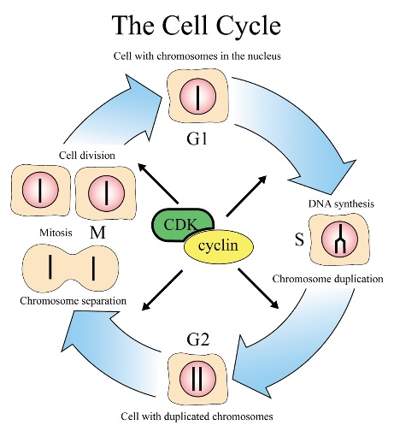**Cdk-cyclin complex**
    - **triggers passage through different stages of cell cycle**
    - **Interaction of Cdk’s & different cyclins _________________________________________**
    - **CDKs & cyclin drive __________________________________________________**

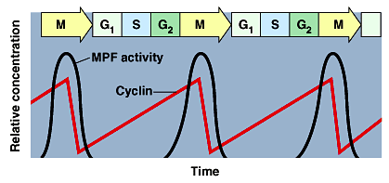

**Proper regulation of cell cycle is so key to life that the genes for these regulatory proteins have been highly conserved**

External Signals of Control – **GROWTH FACTORS**

* + **coordination between cells**
  + **protein signals released by body cells that stimulate other cells to divide**
    - **____________ (contact)**
      * **crowded cells stop dividing**
      * **each cell binds a bit of growth factor**
        + **not enough activator left to trigger division in any one cell**
    - * **to divide cells must be attached to a substrate**
        + **“touch sensor” receptors**

***Example of Growth Factor –***

* **Platelet Derived Growth Factor (PDGF) – made by _____________________!**
  + **made by platelets in blood clots**
  + **binding of PDGF to cell receptors stimulates cell division in connective tissue**

🡪

**Growth Cancers Can Create Cancers**

Regulatory Genes involved in cancer regulation:

* + - **normally activates cell division**
    - **if switched “ON” 🡪**
    - **example: RAS (activates cyclins)**
    - **normally inhibits cell division**
    - **if switched “OFF” 🡪**
    - **example: p53**

**Cancer is essentially a failure of cell division control**

**🡪 unrestrained, uncontrolled cell growth**

**Key Mutations/Hits that Lead to the Development of Cancer**

|  |  |
| --- | --- |
| **Mutation/"hit"** | **effect on tumor suppresor/onco genes** |
| unlimited growth |  |
| ignore checkpoints |  |
| escape apoptosis |  |
| immortality = unlimited divisions |  |
| promotes blood vessel growth |  |
| overcome anchor & density dependency |  |

**What causes these “hits”?**

Mutations can be triggered by…

- -

- -

- -

