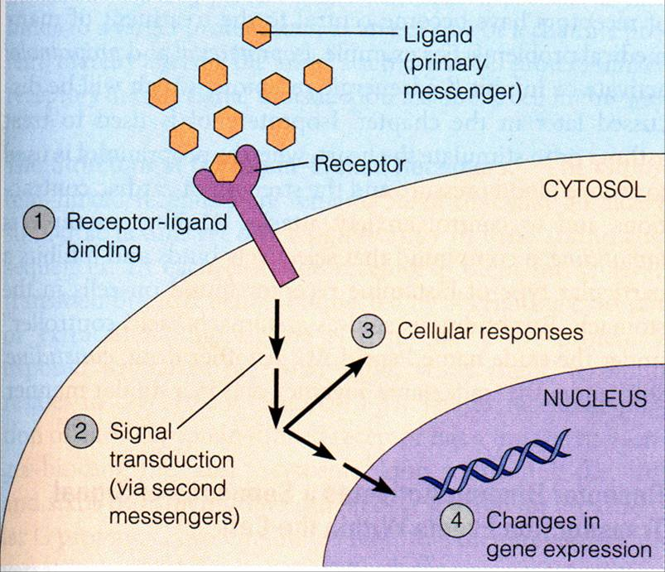
Cell Communication
Big Questions:
How are activities coordinated within an organism?
How do cells communicate to carry out life functions and respond to their environments?
How does a response actually work on a cellular level?

Cell-to-cell communication and messaging

- External signals are converted to responses within the cell

Yeast Sex
- The yeast, S. cerevisiae, has two mating types, a and α
- different mating types locate each other by the factors they secrete

Evolution Connection:
- Pathway similarities suggest that signaling molecules evolved in prokaryotes and were modified later in eukaryotes

What is a Signal Transduction Pathway?

Local and Long Distance Signaling
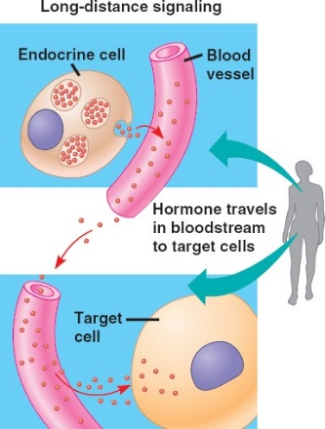

Local Regulators –

Paracrine
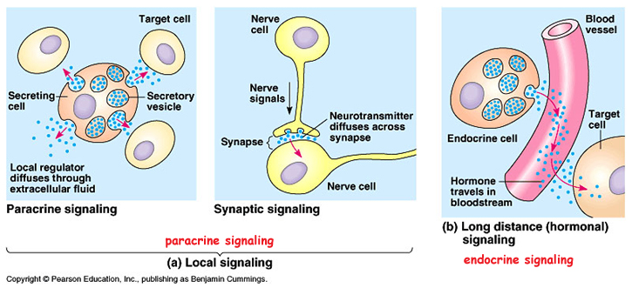
Synaptic

Long Distance Signaling
- ___________________!
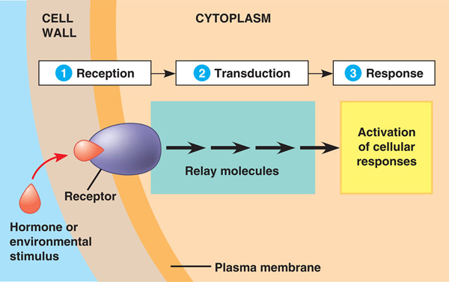
The ability of a cell to respond to a signal depends on whether or not it has a receptor specific to that signal
How does the cell signal get turned into a response? 3 steps:

Step One: Reception

3 Main Types of Membrane Receptors:
1.
2.
3.

G Protein Coupled Receptor

Receptor Tyrosine Kinases

Ligand Gated Ion Channels

- .

Intracellular Receptors

An activated hormone-receptor complex can act as a transcription factor, turning on specific genes
Step Two: Transduction

Multi-step Pathways – can ____________________ a signal so ________ molecules can produce a __________ response

How do STPs work?

- At each step, the signal is transduced into a different form, usually _____________________________________

How is the signal transmitted?

Phosphorylation: Protein ____________ transfer __________________ from ATP to __________________
Dephosphorylation: Protein ____________________ remove __________________ from ________________

Output Response
May occur in the ____________________ or the _________________________

Signaling pathways can also affect the overall behavior of a cell
changes in cell shape

Four Steps of Fine-Tuning a Response:
1.
2.
3.
4.

Signal Amplification
Enzyme cascades ______________________ the cell’s response
- At each step, the number of activated products is much _____________ than in the preceding step

Termination of the Signal

Ligand gated channels G-protein-coupled receptors
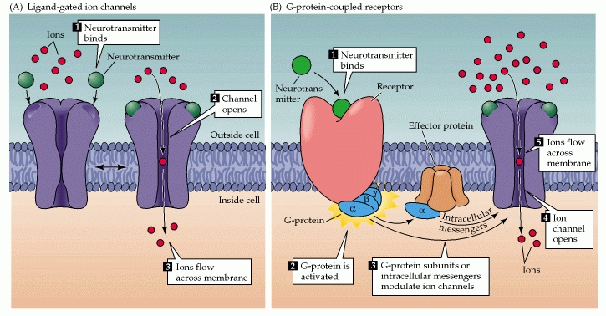

Tyrosine-Kinase Receptors
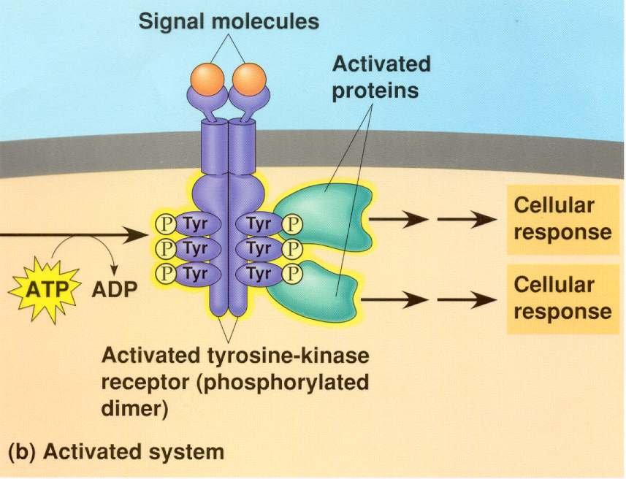

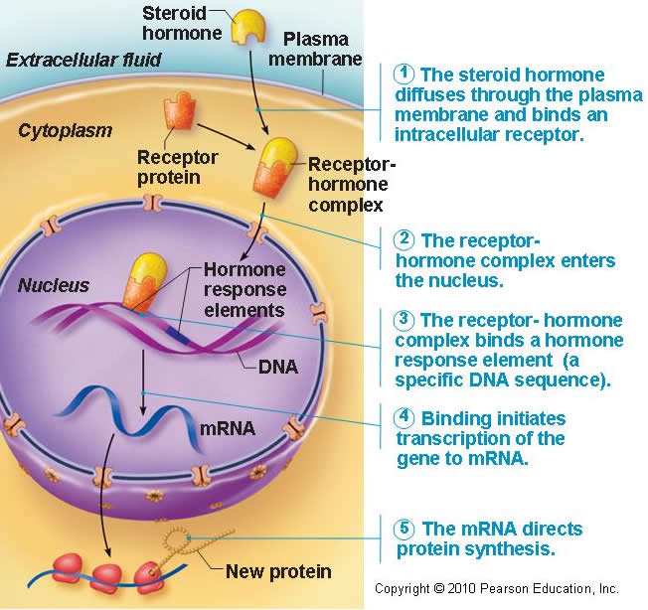

Intracellular Receptors

