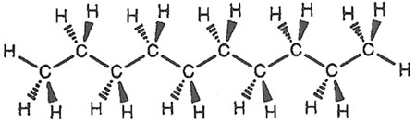
CARBON BACKBONES
Organic Chemistry –

Origins of Life
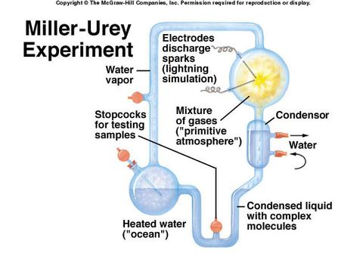

What did he find?

Carbon bonding

Carbon Chains

Hydrocarbons
(a) Structural isomers
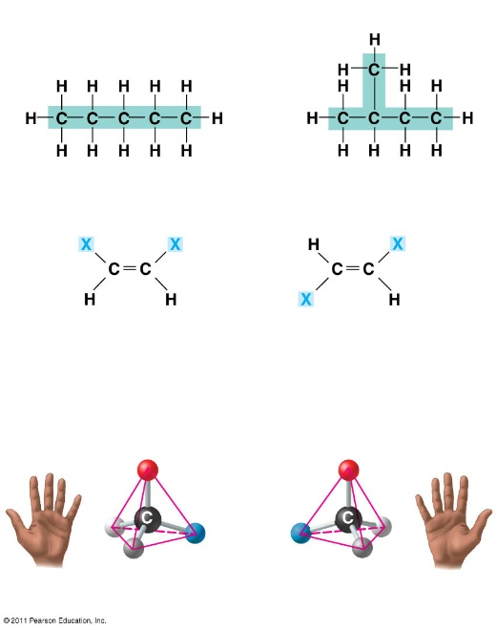
-

Isomers
(b) Cis-trans isomers

trans isomer: The two Xs
are on opposite sides.
cis isomer: The two Xs
are on the same side.
  - Structural isomers
(c) Enantiomers
  - Cis-trans isomers
  - Enantiomers - mirror images of each other

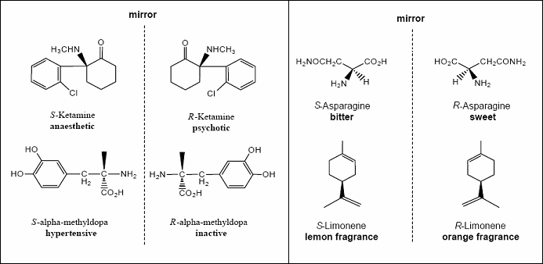
Pharmaceutical Importance of enantiomers

- Differing effects of enantiomers show that organisms are sensitive to even subtle variations in molecules

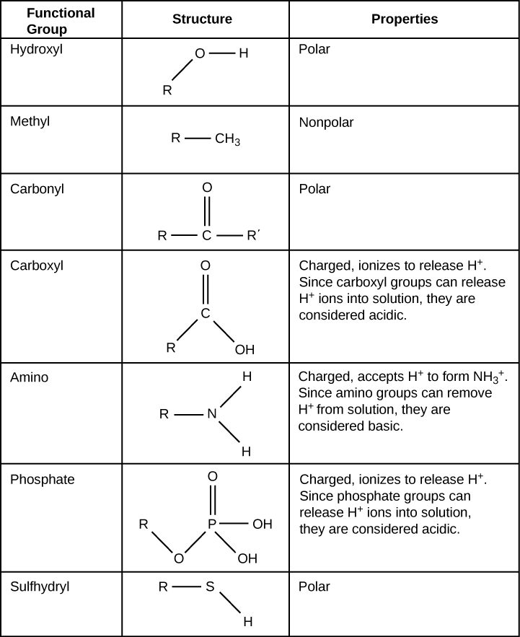
Functional Groups

- The seven functional groups that are most important in the chemistry group:

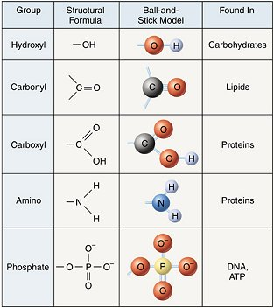

ATP –

