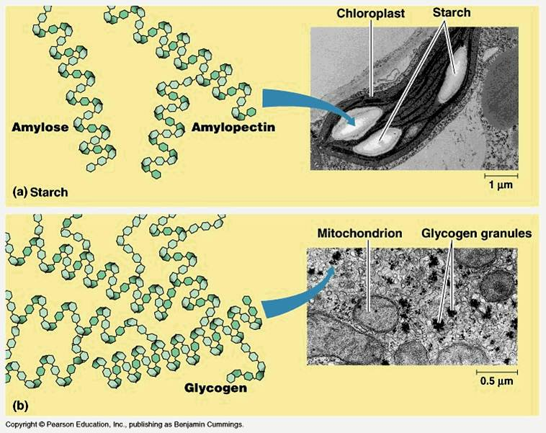
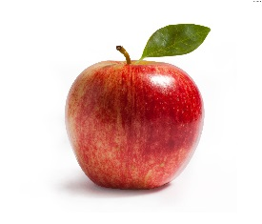
Carbohydrates

Organic vs. Inorganic
Organic =

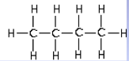
Chemical Formulas
- Structural formulas - show all the atoms and their bonds
- Condensed structural formula - often omit their bonds
CH3-CH2-CH2-CH3

What Will We Be Looking At?
- Macromolecules

Why are Macromolecules Important?
- involved in all of the structures and processes of cells and organisms.
- 4 different types of macromolecules

CARBOHYDRATES
- Contain:
- Ratio of Hydrogen to Oxygen (H:O) =
- Monomers =
- Examples:
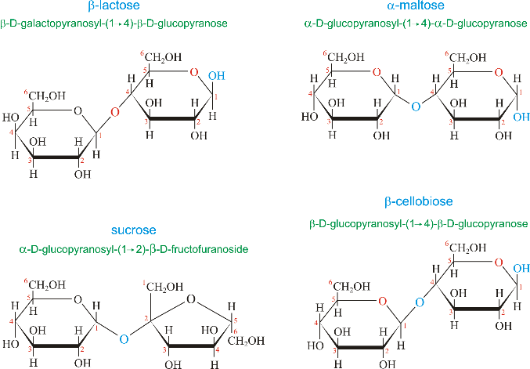
Disaccharides
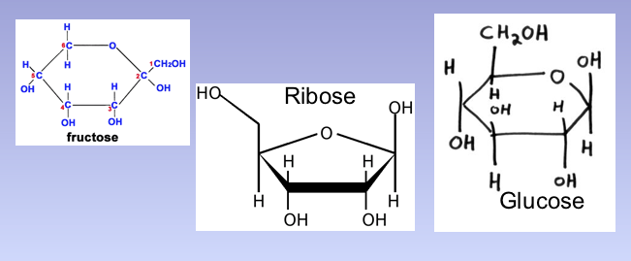
Monosaccharides

*Disaccharides are joined by a:
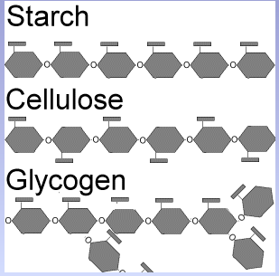
Big Sugars, Big Purposes

Macromolecules Factory
- Condensation/ Dehydration Synthesis

  - (Water is __________ as a part of this process)

- Hydrolysis

  - (Water is _________ as a result of this process)

Carbohydrates are…

- Glucose

- Starch

- Animals store carbohydrates in their body as ___________________ in liver and cells
- When we need more sugar, the body breaks down glycogen using ____________________
- Stored Glycogen is used in a day, and need to be replenished.

- Cellulose –

    - Most abundant organic compound on Earth
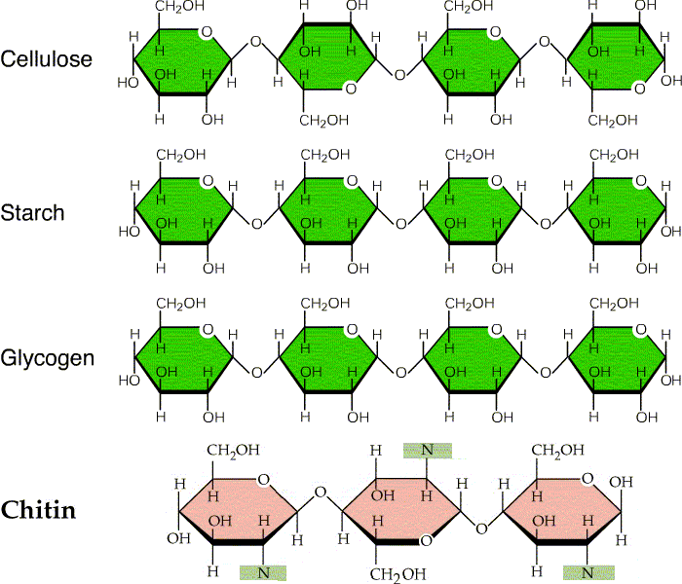
    - What are the building blocks of cellulose? _______________________

- Chitin -

