Breakdown of the Human Genome

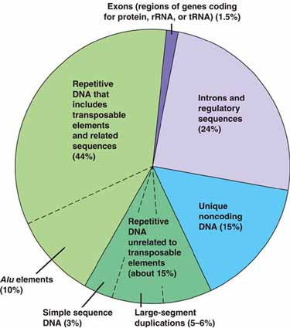

*transposable elements - also known as "jumping genes," are DNA sequences that move from one location on the genome to another.
*Alu elements - primate-specific repeats - comprise 11% of the human genome. They have wide-ranging influences on gene expression.

