AP Biology Review Topics
Evolution
Natural Selection
Sickle Cell Anemia – heterozygote advantage
Directional, Stabilizing, Disruptive and graphs
Species definition
Hybrid zones
Hardy Weinberg Equilibrium
p,q = allele frequency; p²,q², 2pq = population frequency (% of population with genotypes)
practice problem
Conditions for H-W equilibrium to be met:
- no natural selection, no gene flow, large population size, mating is random, no mutation
Evidence for evolution
Biogeography
Fossils – oldest are deepest, sedimentary rock
Anatomy
Homologous – features evolved from same ancestor
Analogous – similar use, different ancestral origin
Embryology – early embryo forms resemble each other
Vestigial – features that have lost their use over time but evidence of or structure remains
Molecular Similarities – genes/proteins conserves across phyla, gene flow
Conserved characteristics
Life, genetic code, metabolism, central dogma (dnarnaproteins), eukaryotic /prokaryotic cell
Phylogeny
Convergent Evolution
Confuses evolutionary relationships – similar solutions to similar problems, diff. ancestral origins
Homology vs. analogy
Cladograms
Genetic Drift
Founder effect, Bottleneck effect reduce genetic diversity
Speciation
Adaptive radiation (finches) – (diff. species evolved from one finch due to diff. environments)
Barriers to reproduction – postzygotic and prezygotic
Allopatric Speciation – caused by geographic isolation
Sympatric Speciation – in a common range/area
Abiogenesis/Miller Urey experiment
Organic molecules possible from inorganic ones
Experiment proved it – shot electricity through a soup and formed essential organic compounds
Ribozymes
RNA as an enzyme – showed mechanism for reproduction of nucleic acids and RNA possible first genetic material
Origin of Life
Prokaryotic cells, Eukaryotic cells, Multicellular organisms, Horizontal Gene Transfer (confuses evolutionary relationships
rRNA is used to examine relationships between bacteria, archae, eukarya
Energy
Exergonic vs Endergonic
Exergonic – releases energy, catabolic/breaks down (cell respiration)
Endergonic – absorbing energy, building/anabolic (photosynthesis)

Cellular Respiration
Redox Reaction
Glycolysis – glucose 2 pyruvate + 2 NADH + 2 ATP net (cytoplasm)
Krebs/Citric Acid Cycle – Acetyl CoA citrate (1st product) 2 ATP + CO₂ + 2FADH₂ + 6NADH
Electron Transport Chain – Chemiosmosis/Phosphorylative Oxidation to make 34 ATP
Chemiosmosis –
H+ stripped from electron carriers (NADH and FADH₂), pumped across membrane to make a high gradient so they can flow back through the ATP Synthase to make ATP
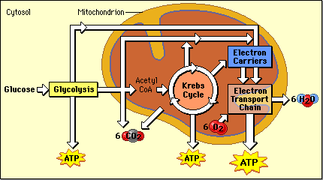
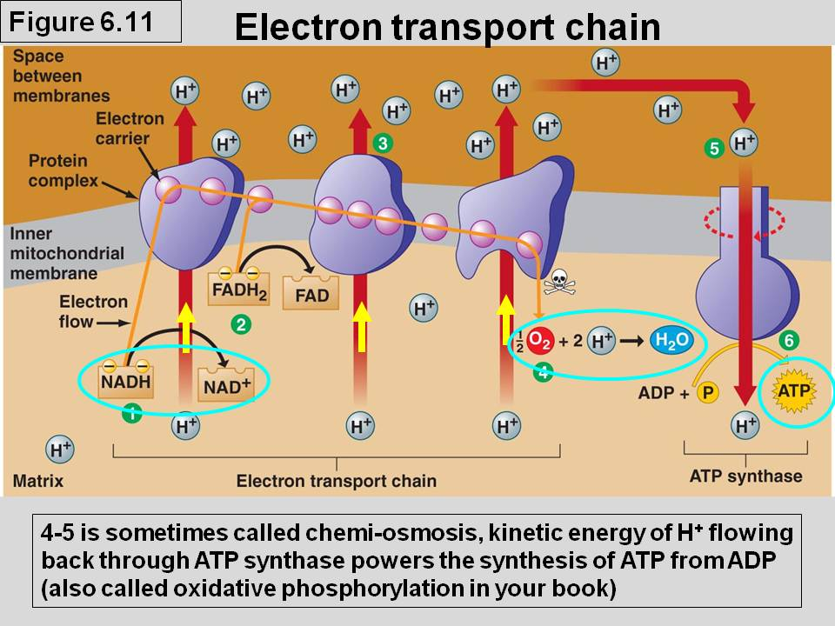

Photosynthesis
Light Reaction – H₂O split and O released, 2 ETCs -ATP and NADPH made for use in dark reaction
Photosystems – absorb light and pass electrons/energy, protein complexes
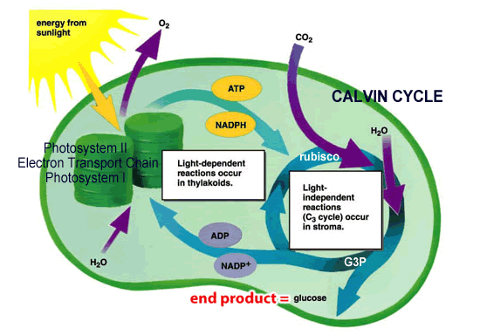
Calvin Cycle – carbon fixation, happens in stroma of chloroplast
uses Rubisco (enzyme) to fix carbon
converts CO₂ to sugar (form of G3P)
uses ATP and NADPH
also known as the C₃ cycle

C₄ and CAM plants
Adaptations for dry environments (prevent
water loss)
CAM – fix carbon at night
C₄ – use different enzyme (PEP carboxylase)
to fix carbon, do Calvin cycle in bundle
sheath cells instead of mesophyll

Environmental matter exchange
Carbon Cycle – Photosynthesis and Respiration
Nitrogen Cycle – Nitrogen fixing bacteria, nitrification and denitrification
Phosphorous Cycle – rocks

Biological Molecules and Cells

Macromolecules
Proteins – NCHO, amine group, carboxyl group, amino acids building blocks, peptide bonds
Functions – enzymes, structure (hair/nails), defense (antibodies), receptors, O₂ transport
Lipids – CHO, long C-H tails that store a lot of energy, triglyceride building blocks (fatty acids +
glycerol), methyl functional groups
Functions – long term energy storage, cushion, insulation, cell membranes (phospholipids)
Carbohydrates – CHO in 1:2:1 ration, monosaccharide building blocks, glycosidic linkages,
glycogen, starch, glucose, cellulose
Functions – energy, structure
Nucleic Acids – CHONP, RNA/DNA, nucleotide building blocks
Functions – instructions for protein building, genetic information
Enzymes
Substrate, Active Site, Enzyme-Substrate Complex, Products
Factors affecting enzyme reaction rates – temperature, pH, salinity, concentration
Allosteric Inhibition – binding of molecule at site away from active site
Competitive Inhibition – molecule blocks active site
Activation energy – energy needed to start a reaction, enzymes LOWer activation energy

Membranes
Fluid Mosaic model
Phospholipids – hydrophilic head, hydrophobic tail, double layer, small nonpolar can pass thru
Cholesterol – stabilizes membrane
Proteins – peripheral, channel, glycoproteins (aid in recognition)
Aquaporins – allow for quick passage of water

Transport
Diffusion – high low concentration, passive (no energy required), moves down conc. gradient
Osmosis – diffusion of water
Active transport – low high concentration, moves up conc. Gradient, endocytosis (taking in
Materials, phagocytosis) and exocytosis (getting rid of), Na/K pumps
Cells
Organelles – ER (smooth and rough), Golgi, Membrane, Ribosomes, Lysosomes, Mitochondria,
Chloroplast, Vacuoles, Peroxisomes, Nucleus, Nucleolus, Chromatin
Path of a protein in a cell endomembrane system – nucleus->ER->Golgi->vesicles->membrane
Organization – cell – tissue – organ – organ system – organism
Stem Cells – pluripotent
Specialization – fated during gastrulation (3 germ layers – endoderm, ectoderm, mesoderm)
Compartmentalization – increased efficiency
Cell Communication
Short Distance - neurotransmitters
Long Distance – hormones
Receptors – receive information
Bacteria – quorum sensing

Signal Transduction Pathways
Reception - Transduction – Response
Ligand – molecule that binds
Phosphorylation Cascade, G protein coupled receptors, Secondary messengers, protein kinase
Molecular Genetics and Heredity (DNA/RNA)

Structure of DNA (deoxyribonucleic acid) - Double stranded helix
Phosphate/Sugar (deoxyribose) backbone
4 nitrogenous bases – adenine, thymine, guanine, cytosine
Carries hereditary information
Packaging – chromatin wound around histones nucleosomes looping/coiling chromosome

Replication of DNA
Semi-conservative model – one new strand one old
Unzips down middle (helicase), base pairing grows new strand (DNA Polymerase III)
Leading and Lagging strand (only can copy in one direction)
Ligase – glues Okazaki fragments (created by lagging strand) back together
Proofreading (DNA Polymerase I) – finds mistakes and repairs them
RNA Primer – attaches to parent strand to initiate DNA replication

RNA (ribonucleic acid) – single stranded
Structure – same as DNA except single stranded, no thymine
Uracil – instead of thymine as a base
Involved in protein synthesis
mRNA – messenger RNA
tRNA – transfers amino acids
rRNA – in ribosomes
Modifications – alternative splicing, 5’ cap, polyA tail
Introns and Exons – exons=expressed regions, introns=non-coding regions
Methylation (turn genes off) and Acetylation (on)

Mutations – permanent change in DNA
Point (Addition, Deletion, Substitution) Sense, Nonsense, Frameshift
Underlying mechanism of evolution
Cause variation in populations
In cell cycle regulation – cancer
Happen during cell division – mispairings or falty division

Protein Synthesis
Central Dogma – DNA RNA amino acids proteins
Transcription – DNA copied into mRNA template
Translation – mRNA translated into amino acids, tRNA delivers amino acids to growing chain
Peptide bond – between amino acids
Chaperonins – help fold proteins into their complex 3D shape
Shape = function

Gene Regulation
Operons (prokaryote) – only turn on when need to use/shut off when don’t need – energy efficient
- promoter, repressor, operator, genes (repressor binds to operator)
- Inducible – off until turned on (lac) and Repressible – on until turned off (trp)
Enhancers (eukaryotic)
Transcription factors (euk)
Methylation and Acetylation (euk)
Epigenetics (euk) – expression of the genome as a result of methylation (turns off genes)
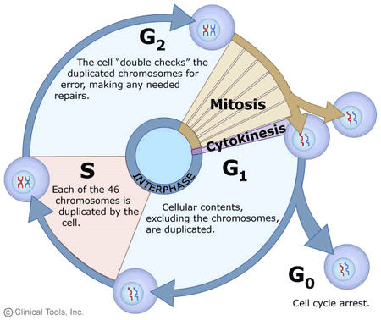
Cell Cycle and Division
4 phases of cell cycle – G₁(growth), S (DNA copied), G₂(growth),
M (mitosis/meiosis)
Interphase – G₁, S , G₂, - cell spends most of time here
G₀ – non-diving acquiescent state of cell – nervous system
cells, liver
Checkpoints – ensure everything going correctly
- Checkpoints ignored cancer
Mitosis – growth and repair, asexual reproduction
one cell division, makes identical copies
4 phases – prophase, metaphase, anaphase,
telophase/cytokinesis

Meiosis – formation of gametes (egg and sperm), sexual reproduction
Two cell divisions, 4 different daughter cells formed
8 phases – prophase I and II, metaphase I and II, anaphase I and II, telophase I and II
1st division – homologous pairs line up across from each other and one set goes to each cell
2nd division – chromosomes line up on equator and chromatids split at centromere
Increases variation
Spermatogenesis (makes 4 sperm) and Oogenesis (1 egg and 3 polar bodies)

Genetics
Mendelian Inheritance – dominance and recessive
Monohybrid cross (Bb x Bb) – 3:1 phenotype ratio
Dihybrid cross ( BbCc x BbCc) – 9:3:3:1 phenotype ratio
Probability rules – do small punnett squares and multiply the chances of the traits together
Sex-linked – either on X or Y – don’t follow 3:1 ratio
Incomplete Dominance – think PINKcomplete – white x red flower makes pink flowers – blend
Codominance – neither allele is dominant over the other – ABO blood groups (AB)
Chi-squared – tests the statistical significance of the results obtained through genetic crosses
- Figure out the expected by doing a punnett square using your assumed relationship
- Observed is the actual amount observed in the cross
- Degrees of freedom are possible outcomes minus 1
- Use .05 column
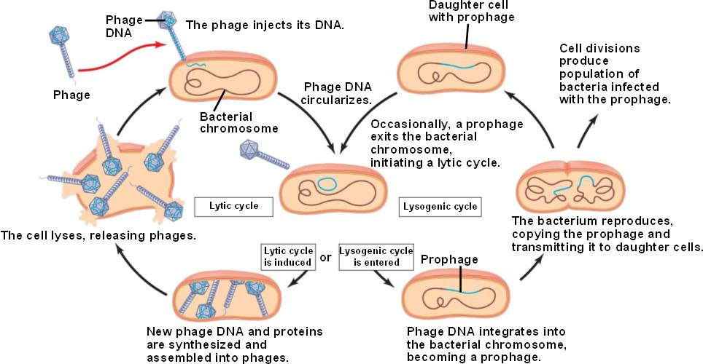
Viral Replication
Lytic Cycle and Lysogenic cycle
Reverse Transcriptase
Lysis – cell ruptures
Vaccines – help defend

Ecology and Plants

Transpiration
Pull of water from leaves to shoots
Moves from high water potential low water potential
Water potential = solute potential + pressure potential
Factors that increase evaporation will increase transpiration
Xylem – carries water, moves upward; Phloem – carries sap, moves downward

Stomates
Help regulate water loss in plants – open and close to let in/out water and gases
K+ ions help to regulate their opening and closing through guard cells

Plant Adaptations for water loss
CAM/C4 plants, waxy cuticle, stomata position on leaves (ie. none on top to be shaded from sun)

Dissolved Oxygen
Temperature, Photosynthetic activity, Decomposition, Mixing/Turbulence, Salinity have effects
Respiration uses up oxygen in aquatic systems, photosynthesis supplies it
Primary Productivity – rate at which plants produce organic compounds in an ecosystem

Populations
Predator-Prey interactions
Competition – Interspecific (between species) and Intraspecific (within species)

Plant Hormones
Auxins – stimulate phototropism (growth towards light)
Tropisms – gravitropism, thigmoidtropism, photropism

Plant Defenses

Invasive Species

