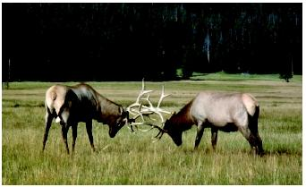
Animal Behavior
Anything an organism does, and how it does it

Behavior is an organism-level phenomenon.

Question: Why do organisms behave in particular ways?

Study of behavior = __________________

Proximate vs. Ultimate
Proximate: _________________________________________________
Ultimate: __________________________________________________

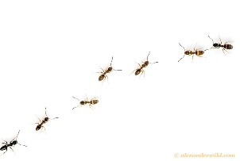
Behavior requires __________________ (particularly among animals)

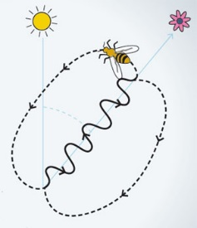
Communication can take several forms:
- _________________________
Substances in the environment, such as pheromones, produced by other organisms
Can contribute to very complex behaviors, such as ant colonies

- _________________________
Multiple lineages of animals have evolved symbolic methods of communication, where information is encoded in abstract symbols (gestures, calls, waggle dances, etc)
Symbolic communication has increased in complexity and diversity over evolutionary time

2 Kinds of Behaviors:
- Innate = _________________________________
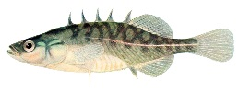
Fixed Action Patterns:

Complex Innate Behaviors:
There’s a limit on the amount of behavioral complexity that can be genetically programmed, there are many examples of complex innate behavior
Example:

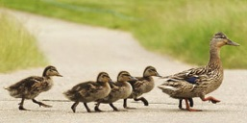
- Learned = _______________________________
5 Types of Learned Behavior:

- Imprinting: _____________________________________________________
______________________________________________________________

- Spatial: ________________________________________________________
example: _______________________________________________________
- Cognition: ______________________________________________________
______________________________________________________________

- Associative: _____________________________________________________
example:________________________________________________________

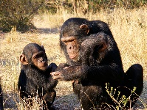
- Social: _________________________________________________________
example:________________________________________________________

Behavior Evolves!!
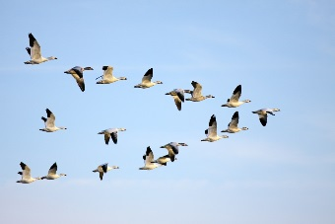
- Behavior and Genetics
Example 1 =
Example 2 =

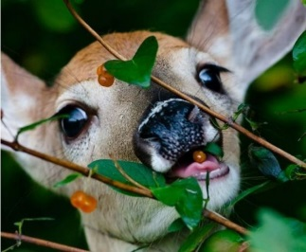
- Behavior and Environment
Environmental constraints determine fitness, which includes behavior
Example 1=
Example 2=

- Behavior and Fitness
Behavior should increase reproductive success
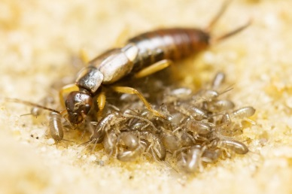
Example 1=
Example 2=
Example 3=
Example 4=

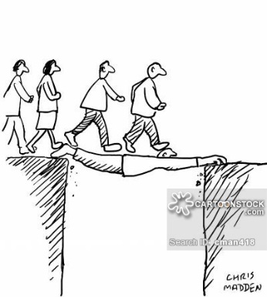
- Altruism – refers to any behavior that an organisms engages in which increases the fitness of other organism while decreasing its fitness
Relatedness
Inclusive fitness

